Final clinical study report

Original title of the Research Project: “Prospective, randomized study to evaluate the safety and efficacy of the treatment of acute spinal cord injury with polylaminin injection”.

CONEP Registration 16723

Process No. 25000.192487/2011-30

Responsible: Tatiana Lobo Coelho de Sampaio

Institution: UFRJ (SINGLE SITE)

CEP of origin: Municipal Department of Health and Civil Defense/RJ

Special Thematic Area: New Drugs, Biosafety

OPINION of approval of the clinical study: no. 38/2013

Table of Contents
1. Clinical study timeline with description of the study design, notifications, and amendments to the clinical research protocol. 3
2. Clinical profile of research participants: 8
3. Experimental treatment, injection procedure and treatment window 10
4. Evaluation of the safety of experimental treatment 12
4.1. Clinical tests 12
4.2. Laboratory tests 13
4.3. Monitoring of Adverse Events 17
5. Evaluation of the efficacy of the experimental treatment 24
5.1. Neurological assessment (AIS classification) 24
5.2. Clinical Outcome 27
5.3. Quality of life questionnaires 33
5.3.1. EQ-5D questionnaire 34
5.3.2. Assessment of independence in patients with spinal cord injury (The Spinal Cord Independence Measure - SCIM) 39
5.4. Electrophysiology 43
5.5. Imaging tests 46
6. Conclusion 48
7. Bibliographic References 48

Clinical study timeline with description of the study design, notifications, and amendments to the clinical research protocol.
The clinical study was approved by the CEP/CONEP system on April 23, 2013 (opinion number 38/2013). This study was designed as a pilot, phase I/II, prospective, randomized, single-blind study to evaluate both the safety and efficacy of the experimental treatment (polylaminin). The main clinical outcome to evaluate the safety of the experimental treatment would be no clinical/neurological deterioration, evaluated through clinical and laboratory tests and monitoring of adverse events. The efficacy of the experimental treatment was evaluated through the neurological progression, using the AIS neurological index, an instrument developed by the American Spinal Injury Association (ASIA) (https://asia-spinalinjury.org/international-standards-neurological-classification-sci-isncsci-worksheet/). The originally approved study design required the selection of 20 research participants with acute SCI involving the cervical spinal cord between C4 and C7 or the thoracic spinal cord, with complete neurological injury (classified as A on the AIS neurological index). The 20 research participants would be randomized into 2 experimental groups: 10 research participants would receive the experimental treatment (treated group) and 10 would receive no treatment (control group). Only the surgeon and 2 laboratory researchers would be aware of the group to which the participant would be assigned (single-blind). All research participants had to have a surgical indication (laminectomy/spinal cord decompression), as the polylaminin treatment had to be injected at the time of surgery, directly into the spinal cord. The surgery, as well as the injection of the treatment, should preferably take place within 72 hours of the trauma. The planned clinical follow-up would take place over 12 months, with regular clinic visits (first 10 days, 1 month, 3, 6 and 12 months after experimental treatment). The research participants would undergo clinical, neurological and laboratory assessments, imaging tests (MRI of the spinal cord), assessments of muscle electrical activity (surface electromyography), quality of life analyses (EQ5D Questionnaire) and assessments of the independence of patients with spinal cord injury (The Spinal Cord Independence Measure - SCIM). All research participants would be followed up with physiotherapy for 200 hours, spread over 1 year.
This clinical protocol, as described above, was followed in compliance with the one approved by the CEP/CONEP system. The first two research participants were randomized to the polylaminin-treated group. The first research participant (ID 01) was included in December 2016 and the second research participant (ID 02) was included in April 2018.
A first amendment was requested to include the Souza Aguiar Municipal Hospital and its respective medical team in the clinical study. Amendment number 1 was approved on March 27, 2018 (Opinion Number: 2.565.966).
Due to the clinical results observed in research participant ID 02, considered exceptional and superior to those that would be expected from the description of the natural progression of this type of disease (SCI, complete injury, AIS A), a request was made for the temporary suspension of the randomization process, in order to ensure that the next 4 research participants would be included in the group treated with polylaminin. For this reason, an Independent Data Monitoring Committee (IDMC) was formed in August 2018, which evaluated the clinical case and issued a report indicating that the experimental treatment possibly benefited the motor and sensory recovery of research participant ID 02. From that moment on, the design of this clinical study was temporarily: prospective, open, and single-arm (polylaminin-treated group only). In this way, the other research participants included in the clinical study received treatment with polylaminin.
On completing the inclusion of 5 research participants (ID 01, ID 02, ID 03, ID 04, ID 05), which would correspond to half of the experimental group treated, the principal investigator sent a partial substantiated report to the CEP, in which she described the clinical results observed in the research participants. In parallel, amendment number 2 was requested to maintain the temporary suspension of the randomization process for the next research participants (excluding the control group). In addition, amendment 2 requested the extension of the research schedule, the inclusion of other health units and collaborating professionals in the clinical study. Amendment number 2 was evaluated and approved by the CEP on June 30, 2019 (Opinion Number: 3.474.884).
All the research participants included in the clinical study (ID 01, ID 02, ID 03, ID 04, ID 05, ID 06, ID 07, ID 08) received the experimental treatment with polylaminin, and were followed up over 12 months. Two research participants were excluded from the clinical study, both due to illicit drug use (considered as one of the exclusion criteria). The use of illicit drugs had been denied by the patients and their families when they were included and signed the Informed Consent Form.
The notification letters about deviations from the research protocol and adverse events were sent for evaluation by the CEP/CONEP system, through the Plataforma Brasil. Out of a total of 27 notification letters, 16 corresponded to reports of clinical complications and deaths of research participants, while 11 reported protocol deviations, including participants excluded from clinical research. The list of forwarded letters is described in figure 1 below.
Recently, the principal investigator submitted an amendment request number 3 on May 25, 2022, requesting the following items: 1) Recruitment of participants in any hospital in the country and not just in the state of Rio de Janeiro, 2) extension of the maximum period for treatment to 10 days, 3) removal of the requirement for there to necessarily be an indication for spinal decompression/fixation surgery, 4) increase in the maximum age for inclusion from 60 to 70 years, 5) performance of follow-up tests in longer time windows, 6) adjustment of the study design, with permanent suspension of the control group. In this request, a report on the clinical results observed with the research participants was also sent. The CEP coordinator of the Municipal Health Department of Rio de Janeiro issued an opinion (Number: 5.555.683), on the date of 8/1/2022, in which he expressed his opinion for NOT approving amendment 3 proposed for the research project, in the following terms: “As a result of the change in the study design, title and methodology, it is necessary, if the researcher is interested, to present a new project with the new methodology proposed for submission for ethical analysis by the CEP/Conep System.” In view of this, the principal investigator, together with her team, decided to end the clinical study and present a new clinical study at a later date, with the new guidelines and methodologies, as suggested by the research ethics committee. The notification of the end of the clinical study was sent to the REC on 9/8/2022 and the status of this notification is under report by the CEP. This final report describes the clinical results observed in all research participants and closes this clinical study. Figure 1 below describes the timeline of the clinical study conducted between 2013 and 2022.

Figure 1: Timeline of the clinical study and the notification letters sent to the CEP/CONEP [Institutional Review Board/National Research Ethics Commission].
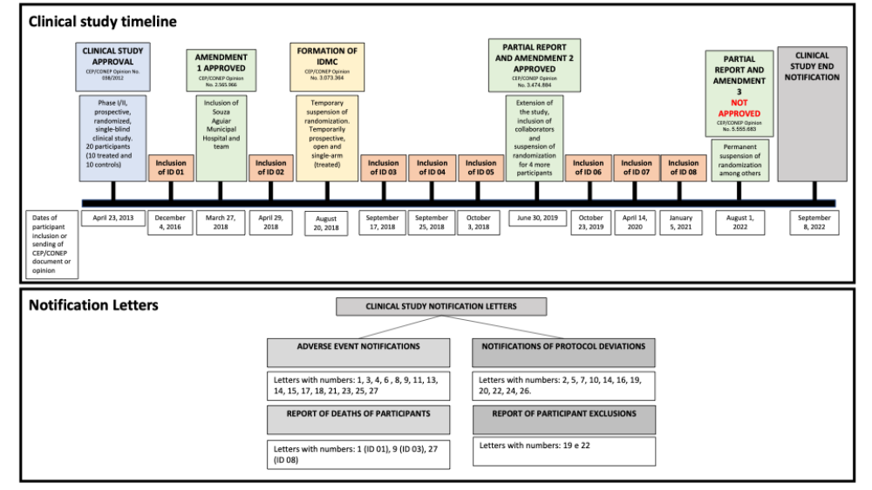

Clinical profile of research participants:
The clinical study included a total of 8 research participants who were recent victims of spinal cord injury (SCI), with complete neurological injury (classified as A on the AIS neurological index), between December 2016 and September 2021. Two research participants were excluded from the clinical study, both due to illicit drug use (considered one of the exclusion criteria), which was denied by both patients and family members at the time of inclusion and signing of the ICF. The exclusion notification letters (numbers 19 and 22) were sent to the CEP/CONEP system through the Plataforma Brasil (see figure 1).
Of the 8 participants evaluated in this clinical study, 3 died from clinical complications related to spinal cord injury (pneumonia/respiratory failure, cardiac tamponade and sepsis). The other 5 research participants were followed up for 12 months, carried out the clinical visits and examinations provided for in the clinical protocol, and by now all have completed all clinical follow-ups. The age range of the research participants varied between 23 and 69 years (average 39.1), with 3 women and 5 men. The causes of spinal cord injury were a fall (4), a car accident (2) and a firearm accident (2), affecting neurological levels between C5 and T10, with 4 participants being quadriplegic and 4 paraplegic. Other vertebral fractures were identified in 3 research participants (ID 02, ID 04 and ID 08), but without injury to the spinal cord. Three research participants had traumatic brain injuries (ID 02, ID 06 and ID 08), all of which were considered to be mild, with no neurological impairment. Other clinical complications such as broncho aspiration, forearm and rib fractures and bilateral pneumothorax were observed in participants ID 1, ID 04 and ID 05, respectively. Different hospitals were involved in the initial hospital care, the injection procedure and the clinical follow-up of the research participants. Table 1 describes all the information relating to the research participants in this clinical study.
Table 1: Description of the profile of the research participants evaluated in the clinical study.
ID | Age | Gender | SCI | Cause | Injury level | Other fractures | Other complications | Inclusion in the clinical study | Treatment injection | Treatment window | Time of treatment injection | Date of death | Reason for death | Initial hospital | Hospital where treatment was given | Hospital discharge or death
ID 01 | 32 | F | 12/3/2016 | Fall from wall | C4/C5 | No | Broncho aspiration | 12/4/2016 | 12/5/2016 | 2 days | During surgery | 12/10/2016 | Respiratory failure | HEGV | HEAL | HEAL
ID 02 | 23 | M | 4/28/2018 | Car accident | C5/ C6 | T8 | Mild TBI | 4/29/2018 | 4/29/2018 | 1 day | During surgery | - | - | HEAPN HCN | HCS
ID 03 | 31 | M | 9/15/2018 | firearm | C7 | No | No | 9/17/2018 | 9/17/2018 | 2 days | Percutaneous injection | 10/7/2018 | Cardiac tamponade and Pericardial effusion | HCE | HCE | HCE
ID 04 | 57 | F | 9/22/2018 | Fall from ladder | T6 | C1, C2, T5, T7 | Forearm and rib fractures | 9/25/2018 | 9/25/2018 | 3 days | During surgery | - | - | HEL HEAT | HMSA | HMSA
ID 05 | 30 | M | 10/2/2018 | firearm | T9/T10 | No | Bilateral pneumothorax | 10/3/2018 | 10/3/2018 | 1 day | During surgery | - | - | HMSA | HMSA | HES
ID 06 | 30 | M | 10/19/2019 | Car accident | C6/C7 | No | Mild TBI | 10/23/2019 | 10/23/2019 | 4 days | Percutaneous injection | - | - | HSJ | HSJ | HVS
ID 07 | 41 | F | 4/9/2020 | Fall | T11 | No | No | 4/14/2020 | 4/15/2020 | 6 days | During surgery | - | - | HMSA | HMSA | HMSA
ID 08 | 69 | M | 1/5/2021 | Fall | T5 and T6 | C7 | Mild TBI | 1/5/2021 | 1/5/2021 | < 1 day | During surgery | 2/27/2021 | Sepsis | HEAL | HEAL | HEAL
Legend: F (female); M (male); SCI (spinal cord injury); Trat. (treatment); H (Hospital); Auto (car), T (thoracic vertebra); C (cervical vertebra), TBI (traumatic brain injury); HEAL: Azevedo Lima State Hospital (Niterói, RJ); HEGV: Getulio Vargas State Hospital (Rio de Janeiro, RJ); HEAPN: Adão Pereira Nunes State Hospital (Rio de Janeiro, RJ); HCD: Copa D’or Hospital (Rio de Janeiro, RJ); HCS: Copa Star Hospital (Rio de Janeiro, RJ); HCE: Hospital Central do Exército (Rio de Janeiro, RJ); HEL: Hospital Estadual dos Lagos (Saquarema, RJ); HEAT: Hospital Estadual Alberto Torres (Rio de Janeiro, RJ); HMSA: Hospital Municipal Souza Aguiar (Rio de Janeiro, RJ); HSJ: Hospital São José (Conselheiro Lafaiete, MG); HVS: Hospital Vila da Serra (Nova Lima, MG); HES: Hospital Ênio-Serra (Rio de Janeiro, RJ); AACD: AACD Rehabilitation Clinic (São Paulo, SP).

Experimental treatment, injection procedure and treatment window
The experimental treatment, which is the subject of this clinical study, consists of a protein called laminin, which polymerizes (hence the name polylaminin) when mixed with a diluent solution. Polylaminin is known to stimulate the growth of axonal extensions both in vitro (neurons grown in the laboratory) and in vivo (spinal cord injury model in rats). In addition, there is evidence that the drug may also exert a neuroprotective effect, which may limit the expansion of the injury that typically follows the initial trauma. This is the first clinical study in the world to investigate the effects of polylaminin in humans.
Polylaminin was injected in a single dose, directly into the spinal cord parenchyma. The administration dose was 1 microgram per kilogram (1 μg/kg) and the final injection volume was determined according to the weight of the research participant. Polylaminin was prepared from a commercial source of human laminin (Millipore Corporation). The preparation of the components for the experimental treatment was carried out in the Extracellular Matrix Biology laboratory at UFRJ by qualified professionals trained for this purpose. The tube containing the appropriate dose for each research participant was labeled with the respective clinical study ID, packed in a thermal box and transported to the hospital where the research participant was staying.
The injection of the experimental treatment was carried out during spinal decompression/fixation surgery in 6 of the 8 research participants (ID 1, ID 2, ID 4, ID 5, ID 7, ID 8). Surgical access was determined according to the type and location of the injury, based on strictly technical criteria according to the research participant's needs. Two research participants (ID 03, ID 06) received the treatment through an X-ray-guided percutaneous injection. The reasons for deviating from the protocol were: 1) no indication for surgery, (ID 03, victim of firearm accident, no vertebral fracture) and 2) inclusion of the research participant after surgery (ID 06). The protocol deviations were forwarded to the CEP/CONEP system.
The surgery, as well as the treatment injection, took place as soon as possible after the SCI. There was a variation in the treatment window, between 1 day and 6 days. The maximum injection time (6 days) of the experimental treatment was due to the unavailability of the surgical center due to the pandemic scenario (participant ID 07, included in the study in April 2020), since all surgical procedures were directed towards medical care for severe cases of COVID-19. On average, patients received treatment 2.3 days after the injury, within the window recommended in the clinical protocol, and considered ideal for the greatest therapeutic effect of polylaminin. No participants received methylprednisolone treatment.

Evaluation of the safety of experimental treatment
This phase I clinical study aimed to assess the safety of treating spinal cord injuries with polylaminin. The methods adopted for this purpose were: 1) clinical tests, 2) laboratory tests and 3) monitoring of adverse events. The research participants were followed up by our medical team over 12 months, with clinical visits carried out at the following times: 1, 2, 10 days and 1, 3, 6 and 12 months after treatment. Laboratory tests were carried out during these same periods to analyze possible hematological changes, markers of liver toxicity, renal toxicity and systemic inflammation. The results are described below.

Clinical tests
The participants were monitored by a team of physiatrists, neurologists and neurosurgeons throughout this clinical study. During medical consultations, vital data such as blood pressure, temperature, pulse and heart rate were measured. The physical examination analyzed the skin (presence or absence of edema or pressure ulcers), intestinal function, urination pattern, body sensitivity, spasticity, reflexes and the presence of pain. All the participants attended the clinical visits established in the protocol (periods of 1, 2, 10 days and 1, 3, 6 and 12 months after treatment). There were some variations in the dates of examinations and visits for some participants, and some tests were not carried out. All protocol deviations were described and sent to the CEP/CONEP system through Plataforma Brasil.

Laboratory tests
Research participants were subjected to blood tests before and 1, 2, 10 days and 1, 3, 6 and 12 months after experimental treatment.
To evaluate renal toxicity, electrolyte, urea, creatinine, sodium and potassium levels were measured. Elevations in creatinine and urea were observed in all participants, but less than 1.2 times the reference values. Apart from this, an alteration in creatinine was detected in participant ID 08 (elevation detected in 3 clinical follow-ups, including the one before treatment) and in urea for participant ID 06 (follow-up 2 days after treatment). The changes in blood electrolytes were possibly related to the pathological process of SCI. Regarding liver toxicity, blood levels of alanine and aspartate aminotransferases (ALT and AST) were evaluated. For alanine and aspartate aminotransferases (ALT and AST), most of the deviations detected were considered mild. The only two moderate elevations were already present before treatment and disappeared on the evaluation of the 10th day of SCI (participants ID 02 and ID08). No serious elevations of liver enzymes were found. The results observed for kidney and liver markers are described in table 2.
Regarding the blood count, a downward trend was observed in the number of red blood cells, hematocrit, hemoglobin, lymphocytes and platelets in all the research participants in the first 30 days after the spinal cord injury, related to the pathological process of the trauma. Some participants showed an increase in leukocytes (ID 01, 07 and 08) during this same period. In general, these blood cell changes observed in the first few months normalized over time and at the 12-month follow-up after clinical treatment most of the values were within the reference values that indicated normality. The results of the blood tests are described in table 3.

Table 2: Evaluation of kidney and liver toxicity markers in research participants.
 | Creatinine  N (%) | Urea  N (%) | ALT (alanine aminotransferase)  N (%) | AST (aspartate aminotransferase)  N (%)
Before treatment
Normal¹ | 7 (88) | 8 (100) | 3 (75) | 1 (20)
Mild² | 1 (12) | 0 (0) | 0 (0) | 3 (60)
Moderate³ | 0 (0) | 0 (0) | 1 (25) | 1 (20)
Severe⁴ | 0 (0) | 0 (0) | 0 (0) | 0 (0)
Total | 8 (100) | 8 (100) | 4 (100) | 5 (100)
Two days after treatment
Normal¹ | 7 (88) | 7 (88) | 4 (80) | 1 (20)
Mild² | 1 (12) | 1 (12) | 1 (20) | 3 (60)
Moderate³ | 0 (0) | 0 (0) | 0 (0) | 1 (20)
Severe⁴ | 0 (0) | 0 (0) | 0 (0) | 0 (0)
Total | 8 (100) | 8 (100) | 5 (100) | 5 (100)
10 days after treatment
Normal¹ | 7 (88) | 8 (100) | 2 (60) | 1 (20)
Mild² | 1 (12) | 0 (0) | 3 (40) | 4 (80)
Moderate³ | 0 (0) | 0 (0) | 0 (0) | 0 (0)
Severe⁴ | 0 (0) | 0 (0) | 0 (0) | 0 (0)
Total | 8 (100) | 8 (100) | 5 (100) | 5 (100)
Legend: 1 Normal applies to the following reference values: creatinine, 0.5-1.2 mg/dL; urea, 18-55 mg/dL; alanine aminotransferase (ALT), less than 41 U/dL, and aspartate aminotransferase (AST), less than 35 U/mL; 2 Mild: > upper limit of normal (ULN) to 2.5 x ULN; 3 Moderate: > 2,5-5 x LSN; 4 Severe: > 5-20 x LSN.

Table 3: Blood tests on research participants during clinical follow-ups
ID | Parameter | Initial | 1 day after treatment | 2 days after treatment | 7-14 days after treatment | 1 month after treatment | 3 months after treatment | 6 months after treatment | 12 months after treatment | Reference values
1 | Red blood cells (M/mm³) | 4.29 | 3.5 | 3.86 | Participant died |  |  |  |  | 3.9 to 5.1
1 | Hemoglobin (g/dL) | 11.1 | 9.4 | 10.8 |  |  |  |  |  | 12.0 to 16
1 | Hematocrit (%) | 34.6 | 28.2 | 30.8 |  |  |  |  |  | 35 to 45 %
1 | Leukocytes (mm³) | 11,100.0 | 12,620.0 | 15,690.0 |  |  |  |  |  | 4,000 to 10,000
1 | Basophils (%) | 0.1 | 0 | 0 |  |  |  |  |  | 0 to 2 %
1 | Eosinophils (%) | 0.7 | 0 | 0 |  |  |  |  |  | 1 to 6 %
1 | Neutrophils (%) | 84.8 | 80.0 | 55 |  |  |  |  |  | 40 to 80 %
1 | Bands (%) | - | 5 | 1 |  |  |  |  |  | 0 to 5 %
1 | Segmented (%) | - | 75 | 54 |  |  |  |  |  | 40 to 80 %
1 | Lymphocytes (%) | 11.2 | 17 | 40 |  |  |  |  |  | 20 to 50 %
1 | Monocytes (%) | 3.2 | 3 | 5 |  |  |  |  |  | 2 to 10 %
1 | Platelets (mm³) | 315,000 | 274,000 | 283,000 |  |  |  |  |  | 150,000 to 450,000
1 | C Reactive Protein (mg/dL) | 1.7 | - | 8.6 |  |  |  |  |  | Less than 1 mg/dL
2 | Red blood cells (M/mm³) | 4.8 | 3.53 | 3.27 | 3.33 | 4.33 | 4.98 | 5.13 | 5.09 | 4.3 to 5.5
2 | Hemoglobin (g/dL) | 15.1 | 11.1 | 10.6 | 10.5 | 13.9 | 14.8 | 16.2 | 16.1 | 13.5 to 18.0
2 | Hematocrit (%) | 47.3 | 34.8 | 32.5 | 33.3 | 41.9 | 43 | 44.8 | 46.5 | 40 to 50 %
2 | Leukocytes (mm³) | 11,200 | 12,100 | 7,600 | 5,800 | 7,400 | 5,060 | 8,480 | 4,540 | 4,500 to 13,000
2 | Basophils (%) | 0 | 0 | 0 | 0 | 0 | 1 | 0.2 | 0.4 | 0 to 2 %
2 | Eosinophils (%) | 1 | 0 | 2 | 2 | 2 | 4 | 0.4 | 2 | 1 to 6 %
2 | Neutrophils (%) | 90 | 83 | 69 | 78 | 75 | 55 | 79.9 | 49.3 | 40 to 80 %
2 | Bands (%) | 2 | 2 | 2 | 4 | 1 | 0 | - | 0 | 0 to 5 %
2 | Segmented (%) | 88 | 81 | 67 | 74 | 74 | 55 | - | 49.3 | 40 to 80 %
2 | Lymphocytes (%) | 6 | 12 | 24 | 13 | 15 | 34 | 9.4 | 41.9 | 20 to 50 %
2 | Monocytes (%) | 3 | 5 | 5 | 7 | 8 | 6 | 10.1 | 6.4 | 2 to 10 %
2 | Platelets (mm³) | 167,000 | 133,000 | 129,000 | 344,000 | 126,000 | 128,000 | 145,000 | 118,000 | 150,000 to 450,000
2 | C Reactive Protein (mg/dL) | 1.60 | 8.9 | 7.30 | 5 | 2 | 0.8 | 2.1 | - | < 1 mg/dL
3 | Red blood cells (M/mm³) | 3.89 | 3.47 | 3.55 | 3.48 | Participant died |  |  |  | 4.3 to 5.5
3 | Hemoglobin (g/dL) | 12.5 | 11 | 11.3 | 10.9 |  |  |  |  | 13.5 to 18.0
3 | Hematocrit (%) | 36.3 | 31.8 | 32.3 | 32.3 |  |  |  |  | 40 to 50 %
3 | Leukocytes (mm³) | 8,300 | 6,500 | 8,000 | 9,800 |  |  |  |  | 4,500 to 13,000
3 | Basophils (%) | 0 | 0 | 0 | 0 |  |  |  |  | 0 to 2 %
3 | Eosinophils (%) | 0 | 0 | 2 | 0 |  |  |  |  | 1 to 6 %
3 | Neutrophils (%) | 86 | 68 | 65 | 80 |  |  |  |  | 40 to 80 %
3 | Bands (%) | 2 | 1 | 1 | 10 |  |  |  |  | 0 to 5 %
3 | Segmented (%) | 86 | 67 | 64 | 70 |  |  |  |  | 40 to 80 %
3 | Lymphocytes (%) | 8 | 27 | 29 | 15 | - | - | - | - | 20 to 50 %
3 | Monocytes (%) | 4 | 5 | 4 | 5 | - | - | - | - | 2 to 10 %
3 | Platelets (mm³) | 191,000 | 131,000 | 146,000 | 217,000 | - | - | - | - | 150,000 to 450,000
3 | C Reactive Protein (mg/dL) | 1.76 | 3.49 | 3.51 | 8.9 | - | - | - | - | < 1 mg/dL
4 | Red blood cells (M/mm³) | 3.27 | 3.1 | 2.93 | 3.23 | 3.15 | 4.22 | 4.73 | 5.04 | 3.9 to 5.1
4 | Hemoglobin (g/dL) | 9.6 | 8.7 | 8.5 | 9.1 | 8.2 | 10.5 | 12.4 | 13.5 | 12.0 to 16
4 | Hematocrit (%) | 26.5 | 25.9 | 24.4 | 27.1 | 25.2 | 32 | 38.4 | 43.7 | 35 to 45 %
4 | Leukocytes (mm³) | 7,200 | 8,400 | 7,600 | 10,600 | 11,900 | 4,800 | 6,900 | 5,120 | 4,000 to 10,000
4 | Basophils (%) | 0.1 | 0 | 0 | 0 | 0 | 0 | 0 | 1 | 0 to 2 %
4 | Eosinophils (%) | 1 | 0 | 2 | 3 | 5 | 5 | 2 | 2 | 1 to 6 %
4 | Neutrophils (%) | 78.2 | 84 | 74 | 89 | 76 | 46 | 60 | 55 | 40 to 80 %
4 | Bands (%) | 2 | 6 | 6 | 4 | 2 | 3 | 3 | 2 | 0 to 5 %
4 | Segmented (%) | 75 | 78 | 68 | 85 | 74 | 43 | 57 | 53 | 40 to 80 %
4 | Lymphocytes (%) | 15 | 10 | 20 | 34 | 13 | 36 | 27 | 36 | 20 to 50 %
4 | Monocytes (%) | 7 | 6 | 4 | 5 | 6 | 13 | 11 | 6 | 2 to 10 %
4 | Platelets (mm³) | 123,000 | 83,000 | 124,000 | 161,000 | 312,000 | 229,000 | 210,000 | 222,000 | 150,000 to 450,000
4 | C Reactive Protein (mg/dL) | - | - | - | - | - | 0.84 | 0.4 | 0.20 | Less than 1 mg/dL
5 | Red blood cells (M/mm³) | 3.3 | 2.63 | 2.36 | 3.41 | 4.04 | - | 4.8 | 4.56 | 4.3 to 5.5
5 | Hemoglobin (g/dL) | 9.7 | 7.7 | 7.5 | 10.4 | 11.6 | - | 13.4 | 13.2 | 13.5 to 18.0
5 | Hematocrit (%) | 29.2 | 23.6 | 20.9 | 30.1 | 35 | - | 42.7 | 39 | 40 to 50 %
5 | Leukocytes (mm³) | 10,800 | 8,400 | 7,200 | 10,200 | 6,800 | - | 3,700 | 10,800 | 4,500 to 13,000
5 | Basophils (%) | 0 | 0 | 0 | 0 | 0 | - | 0 | 0 | 0 to 2 %
5 | Eosinophils (%) | 0 | 2 | 1 | 2 | 2 | - | 2 | 3 | 1 to 6 %
5 | Neutrophils (%) | 90 | 73 | 75 | 75 | 64 | - | 46 | 65 | 40 to 80 %
5 | Bands (%) | 1 | 3 | 2 | 5 | 3 | - | - | 2 | 0 to 5 %
5 | Segmented (%) | 89 | 70 | 73 | 70 | 61 | - | - | 63 | 40 to 80 %
5 | Lymphocytes (%) | 3.1 | 20 | 18 | 18 | 29 | - | 47 | 25 | 20 to 50 %
5 | Monocytes (%) | 6.9 | 5 | 6 | 5 | 5 | - | 5 | 7 | 2 to 10 %
5 | Platelets (mm³) | 162,000 | 115,000 | 123,000 | 390.00 | 447,000 | - | 307,000 | 315,000 | 150,000 to 450,000
5 | C Reactive Protein (mg/dL) | - | - | - | 7.69 | - | - | 0.1 | - | < 1 mg/dL
6 | Red blood cells (M/mm³) | 2.73 | 2.91 | 3.4 | 3.46 | 3.73 | 3.66 | 4.22 | 4.59 | 4.3 to 5.5
6 | Hemoglobin (g/dL) | 7.6 | 8.2 | 9.4 | 9.8 | 10.4 | 10.2 | 12.19 | 13.1 | 13.5 to 18.0
6 | Hematocrit (%) | 24 | 25.9 | 29.5 | 30.3 | 33.1 | 31.6 | 39.5 | 40.4 | 40 to 50 %
6 | Leukocytes (mm³) | 5,000 | 7,020 | 5,610 | 7,810 | 7,020 | 4,630 | 4,770 | 4,720 | 4,500 to 13,000
6 | Basophils (%) | 0 | 0 | 0 | 0.1 | 0 | 0.5 | 0.2 | 0.2 | 0 to 2 %
6 | Eosinophils (%) | 0 | 1 | 4.6 | 4.2 | 2 | 8.4 | 3.8 | 4.7 | 1 to 6 %
6 | Neutrophils (%) | 89 | - | - | - | - | 43.5 | - | - | 40 to 80 %
6 | Bands (%) | 5 | - | - | - | - | - | - | - | 0 to 5 %
6 | Segmented (%) | 84 | 83.2 | 66.7 | 76.4 | 60 | - | 54.9 | 53.4 | 40 to 80 %
6 | Lymphocytes (%) | 9 | 11.1 | 20.7 | 15.1 | 26 | 38.9 | 32.7 | 31.8 | 20 to 50 %
6 | Monocytes (%) | 2 | 4.7 | 8 | 4.2 | 12 | 8.7 | 8.4 | 10.0 | 2 to 10 %
6 | Platelets (mm³) | 123,000 | 128,000 | 155,000 | 242,000 | 248,000 | 218,000 | 206,000 | 193,000 | 150,000 to 450,000
6 | C Reactive Protein (mg/dL) | 0.6 | 6.5 | - | 3.8 | 10.7 | 8.7 | - | 0.75 | < 1 mg/dL
7 | Red blood cells (M/mm³) | 3.6 | 2.9 | 2.9 | 3.11 | 3.21 | 4.7 | 4.14 | 4.34 | 3.9 to 5.1
7 | Hemoglobin (g/dL) | 11 | 8.8 | 8.9 | 8.9 | 11.3 | 12.8 | 12 | 13.4 | 12.0 to 16
7 | Hematocrit (%) | 33.8 | 28.7 | 28.8 | 29.6 | 32.7 | 40.6 | 35.7 | 39.6 | 35 to 45 %
7 | Leukocytes (mm³) | 8,500 | 10,500 | 9,300 | 13,100 | 10,750 | 10,000 | 13,180 | 9,370 | 4,000 to 10,000
7 | Basophils (%) | 0 | 0 | 0 | 0 | 0 | 0 | 0 | 0.2 | 0 to 2 %
7 | Eosinophils (%) | 0 | 0 | 0 | 1 | 3 | 8 | 1 | 1.3 | 1 to 6 %
7 | Neutrophils (%) | 82 | 70 | 97 | 80 | 65 | 57 | 85 | 64.4 | 40 to 80 %
7 | Bands (%) | 3 | 3 | 27 | 3 | 2 | 0 | 3 | - | 0 to 5 %
7 | Segmented (%) | 79 | 67 | 70 | 77 | 65 | 57 | 82 | - | 40 to 80 %
7 | Lymphocytes (%) | 12 | 18 | 2 | 16 | 23 | 28 | 12 | 26.7 | 20 to 50 %
7 | Monocytes (%) | 6 | 12 | 10.1 | 3 | 7 | 7 | 2 | 7.4 | 2 to 10 %
7 | Platelets (mm³) | 244,000 | 266,000 | 227,000 | 59,300 | 349,000 | 330,000 | 316,000 | 259,000 | 150,000 to 450,000
7 | C Reactive Protein (mg/dL) | 2.04 | 9.3 | 9.92 | 1.44 | 0.19 | 0.13 | 0.92 | 0.11 | Less than 1 mg/dL
8 | Red blood cells (M/mm³) | 4.31 | - | 3.37 | 3.13 | 3.19 | Research participant died |  |  | 4.3 to 5.5
8 | Hemoglobin (g/dL) | 13.3 | - | 10.6 | 10 | 9.7 |  |  |  | 13.5 to 18.0
8 | Hematocrit (%) | 38.8 | - | 30.4 | 28.8 | 26.3 |  |  |  | 40 to 50 %
8 | Leukocytes (mm³) | 11,370 | - | 13,160 | 12,900 | 26,030 |  |  |  | 4,500 to 13,000
8 | Basophils (%) | 2 | - | 0 | 0.2 | 0 |  |  |  | 0 to 2 %
8 | Eosinophils (%) | 0 | - | 2 | 3 | 0 |  |  |  | 1 to 6 %
8 | Neutrophils (%) | 110 | - | 83 | - | 89 |  |  |  | 40 to 80 %
8 | Bands (%) | 3 | - | 3 | 3 | 7 |  |  |  | 0 to 5 %
8 | Segmented (%) | 80 | - | 80 | 77 | 82 |  |  |  | 40 to 80 %
8 | Lymphocytes (%) | 11 | - | 10 | 13 | 8 |  |  |  | 20 to 50 %
8 | Monocytes (%) | 4 | - | 5 | 4 | 3 |  |  |  | 2 to 10 %
8 | Platelets (mm³) | 133,000 | - | 101,000 | 387,000 | 435,000 |  |  |  | 150,000 to 450,000
8 | C Reactive Protein (mg/dL) | 11.0 | - | 1.3 | - | 2.82 |  |  |  | < 1 mg/dL

Monitoring of Adverse Events
All participants experienced adverse events during the 12 months of clinical follow-up. Our medical team provided emergency care for each of the events that occurred. Adverse events were reported through notification letters, sent to the CEP/CONEP system through Plataforma Brasil, with a detailed description of the medical complications and treatment applied (see figure 1).
In general, 92 adverse events were observed in the 8 research participants over 12 months of clinical follow-up. The clinical complications were grouped by type of organ or system affected by the health problem, as suggested by Grossman et al. 2012. A total of 23 complications related to infectious processes, 19 neurological and psychiatric complications, 18 complications of the genitourinary system, 12 cardiovascular complications, 9 pulmonary complications, 6 skin complications, 2 hematological complications and 3 complications unrelated to these items were recorded. Table 4 describes all the complications observed in the 8 research participants and their prevalence during the first year after experimental treatment.

Table 4: Clinical complications observed over 12 months of clinical follow-up of the 8 research participants.
Clinical complications over 12 months of clinical follow-up |  | Classification of the clinical complication, number of occurrences and participants who presented the complication | No. of complications
Infection | Urinary tract infection | M (10^{2,4,5,6,7,8}) | 10
Infection | Pyelonephritis | S (1⁴) | 1
Infection | Pneumonia | S (3^{1,6,8}), M (1³) | 4
Infection | Genital herpes infection | L (1²) | 1
Infection | Bloodstream infection | S (3^{2,5,8}), M(1³) | 4
Infection | Fungal skin infection | L (1²) | 1
Infection | Intestinal translocation infection | S (1⁸) | 1
Infection | Sepsis | S (1 ⁸) | 1
Infection | TOTAL |  | 23
Pulmonary complications | Pulmonary insufficiency | S (2¹) | 2
Pulmonary complications | Pulmonary atelectasis | S (1¹), M (1⁴) | 2
Pulmonary complications | Hemothorax | S (2^{4, 5}) | 2
Pulmonary complications | Hypoxemia | S (1¹) | 1
Pulmonary complications | Pleural edema | M (1⁵) | 1
Pulmonary complications | Desaturation | M (1⁵) | 1
Pulmonary complications | TOTAL |  | 9
Neurological or Psychiatric Complications (N/P) | Pain | L (2^{1,5}), M(3^{2,3,7}), | 5
Neurological or Psychiatric Complications (N/P) | Delirium and agitation | S (2^{1,6}), M (2^{2,8}) | 4
Neurological or Psychiatric Complications (N/P) | Headache | L (1²) | 1
Neurological or Psychiatric Complications (N/P) | Reduced level of consciousness | S (1¹) | 1
Neurological or Psychiatric Complications (N/P) | Mental confusion | M (1⁴) | 1
Neurological or Psychiatric Complications (N/P) | Dysautonomia | M (1²) | 1
Neurological or Psychiatric Complications (N/P) | Vertigo | L (2^{2.7}) | 2
Neurological or Psychiatric Complications (N/P) | Muscle spasm | M (1²), L (1⁷) | 2
Neurological or Psychiatric Complications (N/P) | Diabetes insipidus (polyuria) | M (1⁶) | 1
Neurological or Psychiatric Complications (N/P) | Sialorrhea | L (1⁶) | 1
Neurological or Psychiatric Complications (N/P) | TOTAL |  | 19
Hematological Complications | Anemia | S (2^{6.8}) | 2
Hematological Complications | TOTAL |  | 2
Gastrointestinal and/or Genitourinary Tract (GI/GU) Complications | Nausea/vomiting | M (1⁶) | 1
 | Gastric paresis | M (1⁶) | 1
 | Rhabdomyolysis | S (3^{2,6,8}) | 3
 | Constipation | L (5^{2,4,5,7}) | 5
 | Intestinal pseudo-obstruction | S(1⁸) | 1
 | Pyrosis | L (1²) | 1
 | Urinary retention | L (1²), M(1⁴) | 2
 | Prerenal insufficiency | M (1³) | 1
 | Anuria | M (1³) | 1
 | Hematuria | M (1⁵) | 1
 | Diarrhea | L (1⁶) | 1
 | TOTAL |  | 18
Skin complications | Pressure ulcer | M (3^{2,7,8}), S (1⁴) | 4
Skin complications | Rash | L (1⁴) | 1
Skin complications | Surgical wound hyperemia | L (1⁵) | 1
Skin complications | TOTAL |  | 6
Cardiovascular complications | Arrhythmia | S (1¹) | 1
Cardiovascular complications | Bradycardia | S (2¹) | 2
Cardiovascular complications | Hypovolemic shock | S (1¹) | 1
Cardiovascular complications | Septic shock | S (1⁸) | 1
Cardiovascular complications | Hypotension | L(1¹), S (1¹) | 2
Cardiovascular complications | Hypertension | M (1⁸) | 1
Cardiovascular complications | Cardiorespiratory Arrest | S (3^{1,3,8}) | 3
Cardiovascular complications | Cardiac tamponade | S (1³) | 1
Cardiovascular complications | TOTAL |  | 12
Others | Poorly positioned arthrodesis equipment | L (1¹) | 1
Others | Lower limb edema due to heterotopic ossification | M (1⁵) | 1
Others | Lower limb edema | M (1⁸) | 1
Others | TOTAL |  | 3
TOTAL ADVERSE EVENTS |  |  | 92
The first column describes the clinical complications, the second column the types of complications observed and the third column classifies the complications as: S (severe), M (moderate), L (mild). The number in brackets corresponds to the number of adverse events that occurred according to the severity of the event, and the numbers that are raised correspond to the numbers of research participants who had this adverse event. Finally, the fourth column represents the incidence of each adverse event.
Most of the adverse events occurred within the first 30 days after the SCI. The first and second most common occurrences were gastrointestinal/genitourinary (GI/GU) and neuropsychiatric complications, also affecting 7 participants, but involving less severe adverse events. Four participants had skin complications, mainly pressure ulcers. Three of the 8 patients had cardiovascular and pulmonary complications, while hematological adverse events were observed in only 2 research participants. Seven participants had at least one infectious event within one month of the SCI. Seven out of a total of 13 infection complications were considered severe. When we analyzed only the adverse events considered severe, we observed that infections remained the main complication, with an incidence of 63% (5 out of 8 participants). Severe pulmonary and gastrointestinal complications had an incidence of 38% (3 out of 8 participants), cardiovascular, neurological/psychiatric and hematological complications occurred in 25% (2 out of 8 participants) and severe skin ulcers in 17% (1 out of 8 participants). All the clinical complications that occurred in the first 30 days after the spinal cord injury in the 8 patients are described in detail in Table 5.

Table 5. Clinical complications observed in the 8 research participants during the first 30 days after SCI.
Type of clinical complication | Clinical complication classification (total number of each type) |  |  |  | Number of participants
Type of clinical complication | Severe | Moderate | Mild | Total | Number of participants
Infection | 7 | 5 | 1 | 13 | 7
Gastrointestinal tract and genitourinary tract (GI/GU) complications | 4 | 5 | 8 | 17 | 7
Neuropsychiatric complications | 3 | 7 | 7 | 17 | 7
Skin complications | 1 | 3 | 1 | 5 | 4
Cardiovascular complications | 8 | 1 | 1 | 10 | 3
Pulmonary complications | 6 | 3 | 0 | 9 | 3
Hematological Complications | 2 | 0 | 0 | 2 | 2
Other complications | 0 | 1 | 1 | 2 | 2
Total | 31 | 25 | 19 | 75
% Total | 41.34 | 33.33 | 25.33 | 100
¹Refers to cases of lower limb edema (moderate), and one case of positioning problems with the arthrodesis equipment (mild).
Of the 8 participants included in the clinical study, 3 had serious complications related to spinal cord injury and died. Participant ID 01 showed signs of bronchoaspiration on admission and developed severe pneumonia in the first few days of hospitalization. The participant progressed to respiratory failure, had an extubation, followed by cardiorespiratory arrest, and died on the fifth day after treatment. Participant ID 03 had a sudden cardiovascular event on the 20th day of follow-up, with pericardial effusion and cardiac tamponade, followed by cardiac arrest. It is believed that the stroke was caused by a fragment of the projectile hitting the pericardium at the time of the firearm accident. Participant ID 08, on the other hand, presented clinical complications 3 weeks after discharge from hospital, when he was admitted due to a skin ulcer. He died of sepsis two months after inclusion. All serious adverse events that resulted in death were assessed by a medical team to verify the possibility of a relationship between the treatment and the cause of death. None of the 3 deaths that occurred in this clinical study were associated with the therapeutic agent that is the subject of this study, polylaminin. Table 6 below describes the progression of the participants who died.

Table 6: Clinical progression of research participants who died.
 | Date of injection | Date of death | Cause of death | Clinical progression (most important adverse events related to death)
ID 01 | 12/5/2016 | 12/10/2016 | Acute respiratory failure associated with severe pneumonia and extubation | 12/5/2016 Hypovolemic shock | 12/6/2016 Hypotension, pulmonary atelectasis and respiratory failure |  |  |  | 12/6/2016 cardiovascular disorders |  | 12/6/2016 Delirium and neuropsychiatric disorders | 12/7/2016 Pneumonia |  | 12/9/2016 - neuropsychiatric disorders |  | 12/10/2016 - Extubation and respiratory failure, followed by cardiorespiratory arrest
ID 03 | 9/17/2018 | 10/7/2018 | Cardiac tamponade and pericardial effusion | 9/15/2018  renal and neuropsychiatric disorders |  |  | 9/18/2018 bloodstream infection |  |  | 9/26/2018  pneumonia |  | 10/7/2018  Cardiac tamponade and cardiorespiratory arrest
ID 08 | 1/5/2021 | 2/27/2021 | Septic shock | 1/6/21  gastrointestinal disorder, renal disorder and bloodstream infection |  | 1/9/21  anemia |  | 1/11/21  cardiovascular disorder | 1/11/21 lower limb edema |  | 1/14/21  decubitus ulcer in sacral region | 1/18/21  pneumonia | 1/24/21 urinary infection |  | 1/27/21  necrosis in sacral decubitus ulcer | 1/27/21  hypotension, bradycardia, unreversed cardiorespiratory arrest

Analysis of the percentage of deaths in patients with complete injuries (AIS A), as in the case of this clinical study, reveals higher rates. A recent retrospective study carried out in emergency centers in Japan found that 43.8% of cervical SCI patients classified as AIS A died (Higashi et al., 2018). A similar study carried out in Brazil found a mortality rate of 26.2% for all types of cervical SCI, but a percentage of 46.4% among patients with complete injuries (Neumann et al., 2009). Finally, an epidemiological assessment of patients who have suffered spinal cord trauma in the municipality of Rio de Janeiro revealed that the mortality rate for these patients can reach 45% of the affected population (Santos et al., 2012). Therefore, the mortality rate found in this clinical study is within the range shown by other clinical studies of patients with SCI, and is related to the severity of the disease and not to the experimental treatment.

Evaluation of the efficacy of the experimental treatment

To verify the efficacy of polylaminin treatment, this clinical study evaluated the neurological progression of the research participants using the AIS neurological index, an instrument developed by the American Spinal Injury Association (ASIA) (https://asia-spinalinjury.org/international-standards-neurological-classification-sci-isncsci-worksheet/). Complementary assessments of quality of life, surface electromyography and imaging tests also provided evidence that polylaminin treatment benefited the neurological recovery of the research participants. The results are described in the sections below.

Neurological assessment (AIS classification)

All the research participants in this clinical study achieved neurological improvement over time, with a higher than expected progression in the AIS index. Three participants (ID 02, ID 07 and ID 08) recovered motor control, i.e., showed a conversion from AIS A to at least AIS C, at the 1-month post-treatment examination. Another three (ID 04, ID 05 and ID 06) converted to AIS C after 3 months. In particular, participant ID 02 reached the AIS D index already at the 1-month post-treatment clinical follow-up. At the end of 1 year, he showed a return of bladder function, recovery of mobility in the lower and upper limbs, with the ability to walk and move his fingers. Regarding participant ID 06, we observed that in the final neurological assessment (12 months after treatment) there was an improvement in the neurological level from C5 to C7. As well as having voluntary anal contraction and deep anal sensitivity, the participant also recovered bilateral sensitivity at sacral levels S3, S4-5, was able to locate tactile stimuli in the muscles of both legs and gained voluntary contraction at levels C8, T1, L2 and S1 on the left.
Among the paraplegic participants, we found little ability to recover sensory function. Motor improvement in the lower limbs occurred from the third month (participant ID 04) or sixth month of clinical follow-up (participants ID05 and ID07). Gains of 6 to 10 points in the AIS index were observed for these three research participants (ID 04, 05 and 07), although a tendency towards stabilization or reduction was observed in the 12-month post-treatment neurological assessment. The neurological gain was relatively small, but it was consistent, considering that motor recovery in paraplegic patients is rare (Aimetti et al., 2019).
Clinical studies evaluating the natural history of spinal cord injury show that 85% of patients with complete AIS A injuries do not recover voluntary muscle contraction below the injury, and do not convert to AIS C, D or E (Burns et al., 2003; Scivoletto and Donna, 2009; Aimetti et al., 2019). Therefore, the neurological improvement observed in this pilot clinical study indicates that treatment with polylaminin led to neurological improvement in the research participants. It is important to note that the possibility of AIS progression being due to poor classification in the initial neurological test was ruled out because this test was carried out more than 72 hours after the trauma (participants ID 04, ID 06 and ID 07) or because AIS A was sustained at the earliest follow-up (participants ID 02, ID 05 and ID 08). Table 7 describes all the neurological assessments of the research participants.

Table 7. Neurological progression of the research participants over 12 months of clinical follow-up.

Research participant | Neurological assessment before treatment | Neurological assessment during clinical follow-up visits
Research participant | Neurological assessment before treatment | 2 days | 10 days | 1 month | 3 months | 6 months | 12 months
ID 01 | AIS A | Not performed | Research participant died.
ID 02 | AIS A | AIS A | AIS B | AIS D | AIS D | AIS D | AIS D
ID 03 | AIS A | AIS C | Not performed | Research participant died.
ID 04 | AIS A | Not performed | AIS A | AIS A | AIS C | AIS C | AIS C
ID 05 | AIS A | AIS A | AIS A | AIS A | AIS C | AIS C | AIS C
ID 06 | AIS A | Not performed | AIS B | AIS B | AIS C | AIS B | AIS C
ID 07 | AIS A | AIS A | AIS A | AIS C | AIS C | AIS C | AIS C
ID 08 | AIS A | AIS A | AIS A | AIS C | Research participant died.

Clinical Outcome
Neurological progress was different for each individual, and we believe that this is directly related to the type of spinal cord injury. However, other factors such as age, the presence of other injuries or comorbidities, emotional state, and socio-economic conditions may be associated with the differences observed in each participant. The clinical progression of each participant is described in detail below.
Research participant ID 01 suffered an accident when a wall fell on the patient's body, hitting their head and spine. The participant was diagnosed with fractures in the region of the fourth and fifth cervical vertebrae (C4/C5), complete injury, neurological classification with AIS A and quadriplegia. The participant received treatment during surgery to stabilize and fix the spine. The participant presented with bronchoaspiration, which progressed to pneumonia and respiratory failure, and died 5 days after the SCI.
Research participant ID 02 was involved in a car accident, with fractures to the fifth and sixth cervical vertebrae (C5/C6) and the eighth thoracic vertebra (T8), and signs of spinal cord contusion at C5/C6. The research participant had a complete injury, neurological index AIS A, with total loss of sensory and motor function below cervical level 8 (C6/C7). During surgery to stabilize and fix the spine, the participant received treatment with polylaminin and was subjected to electrophysiological tests (Somatosensory Evoked Potential - SSEP, Motor Evoked Potential - MEP, Electromyography), which showed the absence of patency in the somatosensory pathway for the lower limbs and left upper limb, and absence of patency in the motor pathway below C7. Two days after treatment, the research participant maintained an AIS A classification, with no deep sensitivity or anal contraction. The clinical condition of the research participant was quadriplegia. Ten days after the treatment, the participant showed contraction of the anal sphincter, the presence of "islands" of sensitivity in the lower limbs, and was considered to have an AIS B index. At this point, the participant had no mobility. However, on the thirteenth day after treatment, the research participant showed the outline of active movement in the right toe, and from then on, he began to gain a greater capacity for muscle contraction in the lower limbs day by day. There was greater impairment of the lower and upper limbs on the left side of the body. At 20 days post-treatment, the research participant repeated a motor and somatosensory evoked potential test, which revealed the presence of somatosensory pathway patency in all four limbs and partial motor pathway patency, almost complete in the right domain (except C8-T1). During the neurological assessment of the 1-month clinical segment, the research participant had an AIS D neurological index, showing sensitivity in various regions of the body and active movement of the lower and upper limbs. The participant was able to perform knee extension, hip flexion, and change position independently. During a 3-month clinical follow-up, the research participant maintained his AIS D classification and was able to take his first steps without the aid of a walker. The research participant showed improvements in muscle strength and in the ability to flex his little, middle and ulnar fingers, and was able to perform pincer movements in his right hand, but not in his left hand. Electroneuromyography showed that there was voluntary contraction, with rarefaction of the interference pattern, increased amplitudes and discharge frequency in some motor units (first dorsal interosseous muscle, thumb opponent, flexor carpi radialis, triceps brachii, rectus abdominis, vastus medialis, tibialis anterior, gastrocnemius, extensor hallucis longus and tensor fasciae latae bilaterally), characterizing signs of chronic reinnervation. The motor evoked potential test showed latency in the motor pathways for all four limbs (except the left hand). There was an improvement on the previous test, in which no motor potentials were detected in the left hemibody. From the fourth month after treatment, the research participant stopped using a wheelchair and began to walk steadily and with balance, with the aid of a cane. There was a reduction in spasticity in his left lower limb, helping him to recover his gait. At the 6-month clinical follow-up, the neurological index remained AIS D. There was an improvement in the strength, balance and coordination of the lower and upper limbs, and he was able to walk independently and run short distances on an electric treadmill. There was a great improvement in self-care capacity. At 9 months post-treatment, the participant took a urodynamics test and his bladder functioned similarly to normal, and the use of a bladder catheter was discontinued. At the follow-up visit 12 months after treatment, the participant remained AIS D, but was able to walk easily, run on an electric treadmill and perform complex movements such as jumping rope. He showed partial mobility of his fingers, was able to perform pincer movements on both hands and finally returned his ability to write. The motor evoked potential examination at the end of the clinical follow-up showed the return of potentials, with or without facilitation, in the hand muscles bilaterally (abductor digitorum minimus; T1), but with delayed latency. Motor potentials with delayed latencies also returned in the tibial and adductor hallucis muscles (L4, L5 and S1). The SSEP evaluated in the median and tibial nerves was abnormal, but present bilaterally in both nerves. The tests corroborate the clinical improvement observed in participant ID 02, who managed to achieve an unexpected improvement in quality of life and independence, far above the initial prognosis.
Research participant ID 03 was the victim of a firearm and was diagnosed with a transfixing injury to the spinal cord at C7 level, considered to be a severe injury, with neurological index AIS A. The research participant was not referred for surgery because the projectile that hit the spinal cord did not remain lodged inside the spinal canal. The research participant was given a percutaneous injection, in which the treatment was injected directly into the spinal cord, guided by X-ray images. During the clinical evaluation on the second day post-treatment, the research participant presented anal contraction and was classified as AIS C. Five days after the treatment injection, the research participant reported feeling the area of the right foot (mid-foot region) with a rough touch, and on the seventh day reported feeling the area of the calcaneus and mid-foot region of the right foot, also in response to rough touch. Nine days after treatment, the participant reported, with eyes closed, tactile sensations on the plantar surface of the right foot and below the xiphoid process, and showed sensory responses on the left side and motor responses on the left side. On the fourteenth day after treatment, the participant reported feeling palpation in the abdominal region and pressure sensitivity in the lower limbs. On the seventeenth day after treatment, the participant showed movement in both feet (better on the left side) when pressed by the physiotherapist's hand, and felt touch and movement throughout the upper limbs. In the lower limbs, he showed movement in plantar flexion. On the 20th day after treatment, the research participant complained of chest pain while taking a shower and immediately lost consciousness, followed by cardiac arrest and death.
Research participant ID 04 was the victim of a fall accident from a height of approximately 3 meters, diagnosed with complete spinal cord injury at T6 level, with neurological index AIS A. The participant also had forearm fractures, bilateral costal arch fractures, a type III fracture of the odontoid process of C2, a fracture of the anterior arch of Atlas (C1) and bilateral posterior arch, fractures of the bodies of the thoracic vertebrae T5, T6 and T7, but only at T6 was the spinal cord compromised, causing paraplegia. The research participant received experimental treatment during a surgical decompression procedure. In the clinical evaluation two days after treatment, the neurological index remained AIS A. On the eighth day after the experimental treatment, the participant reported sensitivity to touch on the abdomen, on the left side, below the level of the neurological lesion. In the neurological assessment 10 days after treatment, the neurological index remained AIS A, despite the acquisition of active knee extension movement. At the end of the 3-month clinical follow-up, the participant had an AIS C neurological index and was able to activate the pelvis in lateral decubitus and show active movements of the lower limbs. After completing 5 months after treatment, the participant showed improved posture and support of the upper limbs, was able to sustain posture without help and began to make dorsal and ventral decubitus changes on both sides. The participant remained with neurological index AIS C at 6 and 12 months, but with a progressive increase in body awareness, acquiring balance and trunk control, as well as the ability to actively support the hips without support and perform hip and knee extensions. This progress was documented by the increase in the lower limb motor score, rising from 0 to 8 points in the 6-month period, when the expected increase for T6 level injuries is 1.5 points (Aimetti et al., 2009). At the end of 12 months, the research participant showed an improvement in balance and stabilization of all the muscles involved in the center of the body (CORE), with a visible improvement in joint range and muscle strength.
Research participant ID 05 was hit by a firearm projectile, diagnosed with paraplegia with sensory level at T9/T10, with neurological index AIS A. He had a spinal cord injury. He had the most severe spinal cord injury of all those included in the study. At the time of the spinal stabilization surgery, the surgeons reported that the spinal cord was in a liquefied state due to the heat of the firearm projectile. The severity of the injury prevented the participant from showing any neurological improvement during the first 20 days, with the AIS A neurological classification remaining unchanged. However, 23 days after the experimental treatment, the participant showed a contraction in the iliopsoas and quadriceps. In the neurological assessment 30 days after the polylaminin injection, the neurological index was considered AIS C, with perineal sensation, and slight movement of the right and left adductors, as well as mobility of the right quadratus lumborum. After 3 months of treatment, the participant was able to crawl, with active movement being assisted. In the fourth month after treatment, the participant was able to perform gait training on a walker for the first time with his knees extended, using an orthosis. In the fifth month post-treatment, the participant was able to actively crawl without pelvic support, performed active knee extension when sitting and also performed active knee flexion with resistance. At 6- and 12-months post-treatment, the AIS C index was maintained. At the end of 12 months, the participant was able to crawl without any help and walk with the aid of an orthosis, had active knee extension, stabilized his hips and trunk during movements and was able to transfer his body from a bed to a wheelchair with ease.
Participant ID 06 was the victim of a car accident and was diagnosed with complete neurological injury, AIS A, at C5 level. He remained sedated for approximately one week, which made a 2-day neurological assessment impossible. At the 10-day follow-up, the participant was classified as AIS B, with deep anal sensitivity, but without any semblance of movement below the C8 level. At the 30-day follow-up, the participant maintained the AIS B index and C5 level, but acquired sensitivity in the foot, back, buttocks and right thigh, and obtained motor control of flexion of the fingers and abduction of the little finger (C8 and T1), which were absent in the previous assessment. At the 3-month follow-up, the participant had acquired voluntary control of the anal sphincter and active movement, albeit insipient, was detected in the lower limbs, which led to conversion to AIS C. He was able to remain in a sitting posture, with trunk support, and showed an outline of dorsiflexion and plantar flexion on the right side. In the fourth month, the research participant was able to hold the cup and slowly move his feet. In the period that followed, the COVID-19 pandemic caused the participant to suspend his physiotherapy sessions in Rio de Janeiro. As a result, the 6-month examination detected a return to the AIS B index, with loss of the motor function previously detected, but with a progression in the level of the lesion from C5 to C6. At the 12-month follow-up after returning to the physiotherapy routine, the participant again showed an AIS C index with voluntary motor control of sphincters and sketching of movement in the lower limbs, as well as having progressed one more neurological level to C7. The motor control gain of the participant was detected in the comparison between the electrophysiological tests carried out immediately after the trauma and after 12 months, where the acquisition of motor evoked potentials for hand muscle control can be seen. At the end of 12 months, the participant was able to identify pressure during bladder filling and showed achievements in his self-care skills. During feeding, the participant was able to hold spoons with adapters and perform the movements on his own. The participant reported being able to pick up objects from the floor by resting his body on the wheelchair. He can transfer his body from the wheelchair to the bed or car with complete independence.
Research participant ID 07 suffered a fall of approximately 4 meters, diagnosed with a complete injury, with a fracture of the T11 vertebra, considered to be AIS A, with total paralysis of the lower limbs. Due to the COVID-19 pandemic, the surgeries were delayed, and the medical team was able to perform the fixation surgery and the injection of the polylaminin treatment into the spinal cord only 6 days after the SCI. In the 2-day and 10-day evaluations, the research participant was considered to be AIS A. Due to the isolation conditions imposed by the pandemic, the participant was unable to undergo any physiotherapy procedures during the first 2 months of clinical follow-up, yet at the 30-day follow-up, voluntary sphincter contraction and contraction in a non-key muscle were observed, which led to the AIS index progressing to C. From June onwards, the participant began receiving home physiotherapy once a week, which may have led to a progression of 10 points in the motor score at the 6-month follow-up, maintaining the AIS C classification. This classification was maintained at the 12-month follow-up.
Research participant ID 08 was the victim of a fall from a ladder from a height of approximately 5 meters due to a shock from a high-voltage wire. The research participant was diagnosed with complete injury, level T4, with neurological index AIS A, and paraplegia. Due to the Covid-19 pandemic, the participant did not receive any physiotherapy care. At the 2-day and 10-day follow-ups, he maintained the AIS A neurological index classification. However, at the 30-day post-treatment examination, the participant began to show deep anal sensitivity and voluntary contraction movement in non-key muscles, which caused him to progress to AIS C. The participant was the victim of an infected decubitus ulcer which developed into sepsis, and he died two months after the trauma.

Quality of life questionnaires

The research participants were subjected to two types of quality of life questionnaire: the EQ-5D and the Spinal Cord Independence Measure (SCIM). The main aim of both methods was to assess the impact of polylaminin treatment on the participant's quality of life, self-care ability, mobility, emotional state and degree of independence. The EQ-5D and SCIM questionnaires were applied before treatment and during clinical evaluations at 1 month, 3, 6 and 12 months after treatment. The responses are subjective, reported by each research participant and are described without any interference from the evaluator. The results obtained in the five participants who completed the 12-month follow-up (ID 2, 4, 5, 6, 7) are described below.

EQ-5D questionnaire

The ED-5D questionnaire is a generic, multidimensional questionnaire, not specific to a particular age, disease or treatment group, which has been widely used in clinical studies. It consists of 15 items covering 5 domains: (1) mobility, (2) personal care, (3) usual activities, (4) pain/ discomfort, (5) anxiety/depression. It also has a graph to measure health status from the patient's own perspective.
In this study we observed an improvement in all the aspects assessed in the 5 research participants (ID 2, 4, 5, 6, 7). Regarding the mobility item, before the clinical treatment, the 5 research participants (ID 2, 4, 5, 6, 7) were limited to staying in bed, however, at the end of the study, only 2 of the 5 participants were limited to bed, 1 reported having some problems walking and 1 reported having no problems walking (one participant answered none of the above). There was an increase in independence, so that before the study all 5 participants said they were unable to dress or wash themselves, and at the end of the clinical study, only 1 participant continued to have this inability, 2 said they had some problems dressing or washing themselves and 2 said they had no problems washing or dressing themselves. In addition, with regard to personal care, before treatment all 5 participants considered themselves unable to carry out normal activities and all of them, at the end of the study, had only a few difficulties in carrying out normal activities. A reduction in the pain reported by the research participants was also observed. Before treatment all 5 participants complained of extreme pain and discomfort, and 12 months after treatment, 4 reported feeling no pain or discomfort at all. There was a reduction in anxiety over time. Three out of 5 participants considered themselves moderately anxious at the start of the study and at the 12-month clinical follow-up, 4 participants reported not being anxious or depressed. The results obtained are described in general in table 8, and individually (each participant) in table 9 below.

Table 8: Analysis of the EQ-5D questionnaire of the 5 research participants (ID 2, 4, 5, 6, 7), described by each item evaluated.
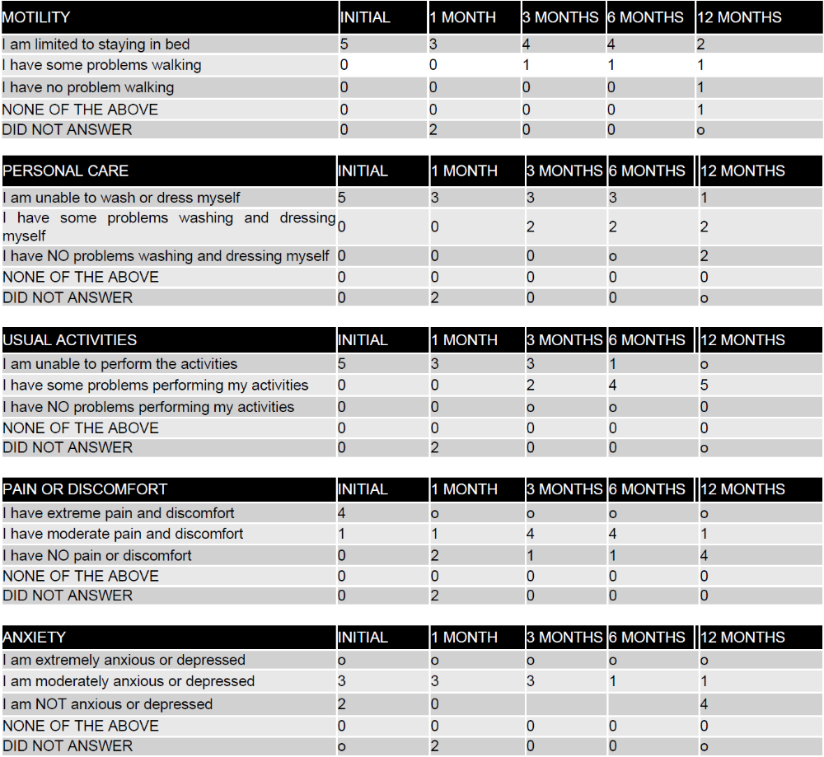
Legend: The first column describes the items evaluated in the EQ-5D questionnaire (grouped by theme, with possible answers for each item) and the other columns describe the follow-up visits. The numbers in each column correspond to the number of participants who selected the respective answer within each item evaluated.
Table 9: Detailed analysis of the EQ-5D questionnaire with results obtained from each of the 5 research participants.
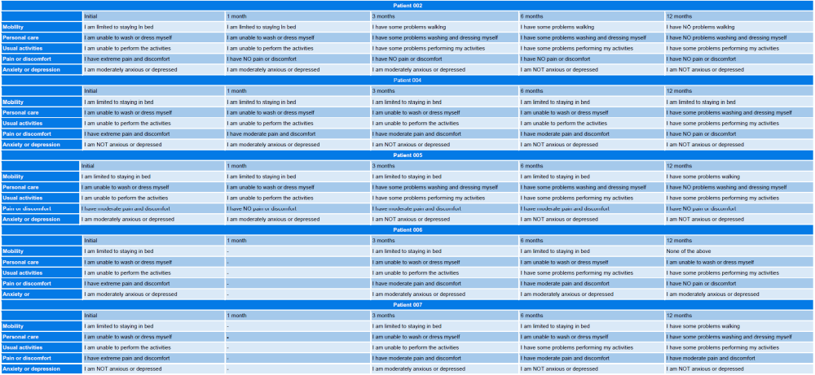
Legend: The first column describes the items evaluated in the EQ-5D questionnaire (grouped by theme) and the other columns describe the follow-up visits, with the respective answers selected by each research participant.
Finally, each research participant was asked how healthy they considered themselves to be at the time of the clinical follow-up. The value could vary on a scale from 0 to 100, with the best state of health corresponding to a score of 100 and the worst state being a score of zero. Analysis of the results revealed that there was an increase in the score over time in most of the clinical cases, with 4 of the 5 participants considering their health to be between 80 and 100 points at the end of the study. The graph below shows the score of each participant throughout the clinical follow-ups (Figure 2).

Figure 2: Graph on the Visual Analog Scale
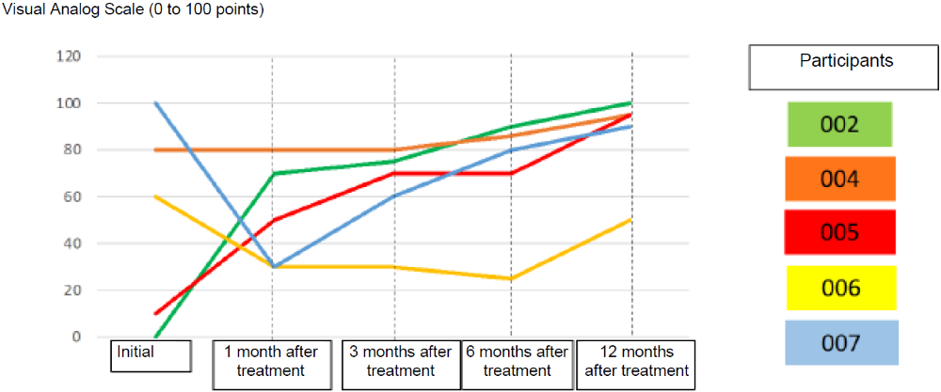
Legend: The graph corresponds to the visual analog scale, where the participant evaluates their health on a scale of 0 to 100 points. The scores of research participants ID 02, 04, 05, 06 and 07 are represented by the colors green, orange, red, yellow and blue, respectively.

Assessment of independence in patients with spinal cord injury (The Spinal Cord Independence Measure - SCIM)

The Spinal Cord Independence Measure (SCIM) is a method widely used in clinical studies involving SCI. It consists of 94 categories, with 18 items divided into 3 sub-scales (areas of function): (1) self-care (eating, bathing, dressing, personal hygiene), (2) breathing and sphincter control (bladder and bowel), and (3) mobility. The points obtained range from 0 to 100 and make it possible to estimate the clinical condition, patient comfort and the social interaction capacity of the patient. All five participants who completed the 12-month follow-up (ID 2, 4, 5, 6, 7) showed a progressive increase in independence, although the SCIM-III scores fluctuated mainly after the third month. There was an improvement in self-care, sphincter control and mobility. In particular, participant ID 02 started the clinical study with a score of 10 and reached 95 points at the end of 12 months. The results obtained in general are described in table 10 and the individual results in table 11 below.

Table 10: Analysis of the SCIM questionnaire of the 5 research participants (ID 2, 4, 5, 6, 7).
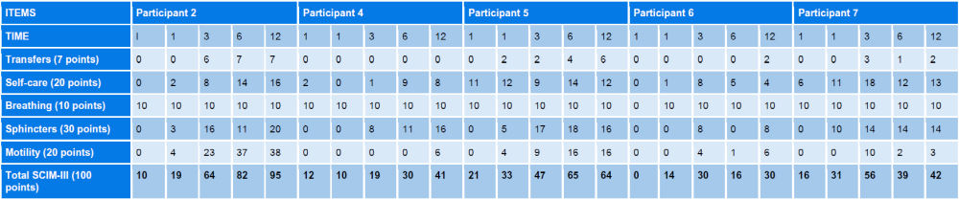
Legend: The first column describes the items grouped by theme in the SCIM questionnaire, and the other columns describe the scores obtained at each clinical follow-up: I (initial), 1 (1 month after treatment), 3 (1 month after treatment), 6 (6 months after treatment) and 12 (12 months after treatment).

Table 11: Analysis of the SCIM questionnaire on scores obtained in each category by the 5 research participants.
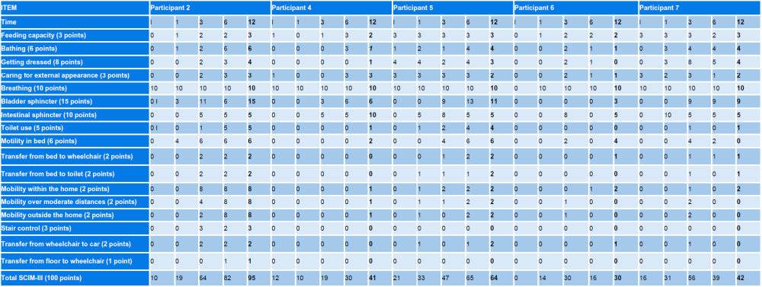
Legend: The first column shows the items on the SCIM questionnaire, and the other columns show the scores obtained at each clinical follow-up: I (initial), 1 (1 month after treatment), 3 (1 month after treatment), 6 (6 months after treatment) and 12 (12 months after treatment).

Figure 3: Graph of the scores obtained on the SCIM questionnaire by the research participants over time

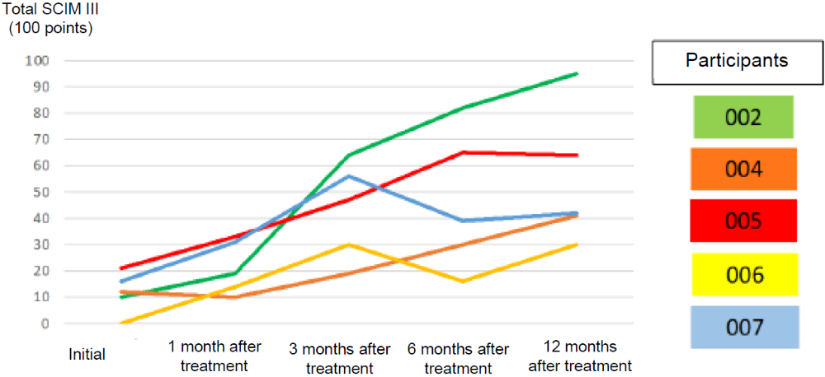
Legend: The graph corresponds to the SCIM questionnaire score curve, on a scale of 0 to 100 points. The scores of research participants ID 02, 04, 05, 06 and 07 are represented by the colors green, orange, red, yellow and blue, respectively.

Electrophysiology
Electrophysiological assessments were carried out using surface electromyography tests performed at follow-up visits at 1 month, 3, 6 and 12 months after the experimental treatment, as defined in the research protocol. Participants ID 01, 03, 08 did not undergo surface electromyography tests because they died. Participants ID 02, 04 and 05 all underwent surface electromyography tests, as planned for the clinical study (with the exception of the 3-month visit of participant 04). However, the last participants ID 06, ID 07 did not undergo surface electromyography tests. Protocol deviations were forwarded to the CEP/CONEP system through notification letters.
Research participant ID 02 showed a gain in electrical conductivity in the 3-month, 6-month and 12-month electromyography exams compared to the 1-month exam, which corroborates the neurological progression of this participant, who progressed from AIS A to D. On the other hand, we found no change between the initial assessment and the 12-month surface electromyography examination of research participants ID 04 and ID 05, which means that in these cases electromyography was not sensitive enough to detect the voluntary contractions observed in the final neurological examinations of these research participants, who progressed from AIS A to C.
In addition, some research participants ID 2, 6 and 7 were subjected to motor and somatosensory evoked potential tests (MEP and SSEP, respectively). This test was not included in the clinical protocol, but was recommended by the medical team to assess the patients' clinical progress.
In research participant ID 02, initial SSEP patency was observed only in the right upper limb, while max PE was normal only up to C7 (Fig. 4A). No evoked potentials were observed in the lower limbs. Max EP at the end of follow-up showed the return of potentials, with or without facilitation, in the hand muscles bilaterally (abductor digitorum minimus; T1), but with delayed latency. Motor potentials with delayed latencies also returned in the tibial and adductor hallucis muscles (L4, L5 and S1) even without facilitation (Fig. 4A). The final SSEP was assessed in the median and tibial nerves and was found to be abnormal, but present bilaterally in both nerves.
The initial SSEP of participant ID 06 detected normal conduction in the median nerves (C6) and reduced amplitudes in the tibial nerve (L4-S3; not shown). Max EP was present and symmetrical up to C6-C7 and absent at C8-T1 and in the lower limbs. At the end of the follow-up, the SSEP remained unchanged, but the max EP recorded a previously absent potential at C8-T1 in the right hand (Fig. 4B).
Participant ID 07 with injury at T10 had normal SSEP and max EP in the upper limbs in all tests. The initial SSEP revealed an unequivocal loss of patency in the lower limbs bilaterally. On the other hand, the final evaluation indicated the presence of low-amplitude potentials identified by the P40/N50 markers in the tibial nerves (Fig. 4C). MEP remained unchanged over the 12 months (not shown).

Figure 4 - Analysis of motor evoked potential (MEP) and somatosensory evoked potential (SSEP) tests
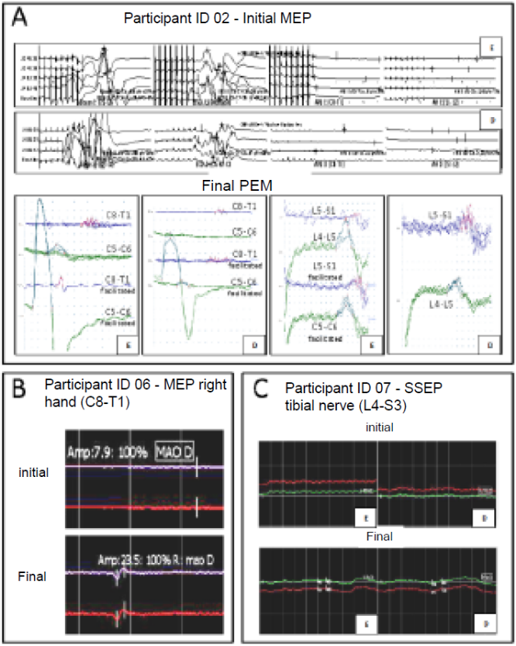
Legend: The figure shows graphs describing the results of the motor evoked potential (MEP) and somatosensory evoked potential (SSEP) tests of research participants ID 02 (A), ID 06 (B), ID 07 (C). The letters D indicate results obtained on the right and E results obtained on the left.

Imaging tests
The research participants were subjected to imaging tests in order to accurately locate the spinal cord injury, help classify the type of injury and measure its area of extension. The examinations were carried out before the surgical procedure and 6 months and 12 months after treatment with polylaminin. The 5 participants who completed the 12-month follow-up (ID 2, 4, 5, 6, and 7) had their initial and final imaging tests compared. Participant ID 02 developed a large cystic cavity within the spinal cord that occupied most of its cross-section (Fig. 5A). Participant ID 04 also developed a cavity at the site of the injury (Fig. 5B). Participant ID 06 showed, at 12 months post-treatment, only a narrow band of normal signal remaining in the center of the spinal cord (Fig. 5C). Participant ID 05 did not have an MRI due to the presence of metal fragments from the projectile. A comparison of the CT images, before and after treatment, did not reveal any notable changes over the course of the clinical follow-ups. Participant ID 07 had only the final MRI performed because there was no MRI machine in the hospitalization center and it was not possible to transfer the patient for the exam during the peak of the pandemic. Analysis of the final MRI also indicated the presence of a large area of hypersignal at the site of the injury (not shown). Overall, the image analyses suggest that polylaminin treatment did not lead to any image-detectable changes in the cavitation process expected to occur after spinal cord injury.

Figure 5: Analysis of imaging scans of the spinal cord of the research participants.
ID 06
ID 04
ID 02
ID 02

Conclusion
This clinical study, although a pilot study, demonstrated that intramedullary injection of polylaminin is a safe procedure because it did not lead to any detectable neurological deterioration and because no atypical adverse effects, other than those expected for SCI patients, were observed. In addition, conversion of the AIS index from A to C or D was observed in 6 of the 8 participants, a neurological progression above that described in the scientific literature, which suggests that treatment with polylaminin was effective.

Bibliographic References
- Aimetti AA, Kirshblum S, Curt A, Mobley J, Grossman RG, Guest JD. Natural history of neurological improvement following complete (AIS A) thoracic spinal cord injury across three registries to guide acute clinical trial design and interpretation. Spinal Cord 2019;57:753-762.
- Burns AS, Lee BS, Ditunno JF Jr, Tessler A. Patient selection for clinical trials: the reliability of the early spinal cord injury examination. J Neurotrauma 2003;20:477-82.
- Grossman RG, Frankowski RF, Burau KD, et al. Incidence and severity of acute complications after spinal cord injury. J Neurosurg Spine 2012;17:119-28.
- Jiang F, Jaja BNR, Kurpad SN, et al. North American Clinical Trials Network Collaborators. Acute Adverse Events After Spinal Cord Injury and Their Relationship to Long-term Neurologic and Functional Outcomes: Analysis From the North American Clinical Trials Network for Spinal Cord Injury. Crit Care Med, 2019;47:e854-e862.
- Higashi T, Eguchi H, Wakayama Y, Sumi M, Saito T. Risk factors associated with mortality after traumatic cervical spinal cord injury. OTA Int 2018;1:e003.
- Neumann CR, Brasil AV, Albers F. Risk factors for mortality in traumatic cervical spinal cord injury: Brazilian data. J Trauma 2009;67:67-70
- Santos, TSC, Guimarães RM, Boeira, SF. Spinal cord injury epidemiology in public emergency rooms in the municipality of Rio de Janeiro. Escola Anna Nery 2012;16,4:747-753
- Scivoletto G, Di Donna V. Prediction of walking recovery after spinal cord injury. Brain Res Bull 2009;78:43-51.

