EXERCISE, BIOMARKERS AND FUNCTIONALITY IN ALZHEIMER'S DISEASE AND IN FRAILTY
Emmanuel Dias de Sousa Lopes¹, Flávia Gomes de Melo Coelho², Carlo José Freire Oliveira³, Jonatas da Silva Catarino³, Bruno Naves Ferreira², Sheilla Tribess^{2,4}, Marina de Melo Reis⁴, Ugo Costa Severino⁵, Jair Sindra Virtuoso Júnior^{1,2,4}

¹ Postgraduate Program in Health Care, Federal University of Triângulo Mineiro, Uberaba, Minhas Gerais, Brazil.
² Postgraduate Program in Physical Education, Federal University of Triângulo Mineiro, Uberaba, Minas Gerais, Brazil.
³Laboratory of Immunology, Institute of Natural and Biological Sciences, Federal University of Triângulo Mineiro, Uberaba, Minas Gerais, Brazil
⁴Departament of Sport Sciences, Federal University of Triângulo Mineiro, Uberaba, Minhas Gerais, Brazil.
⁵Department of Medicine, Federal University of Triângulo Mineiro, Uberaba, Minas Gerais, Brazil.

Correspondence: Jair Sindra Virtuoso Junior, Postgraduate Program in Health Care, Federal University of Triângulo Mineiro, Av. Getúlio Guaritá nº 107, 38025-440, Uberaba, Minas Gerais, Brazil.
E-mail: jair.junior@uftm.edu.br

Abstract
Background: Physical exercise increases motor functionality, synthesis of neurotrophic factors, including brain-derived neurotrophic factor (BDNF), which is a factor involved in neuroplasticity, and improvements in cognitive function in elderly patients without dementia. Besides, physical exercise modulates various aspects of the immune system, something that may be beneficial for the treatment of neurodegenerative disorders, such as Alzheimer's disease. Thus, the aim of this study was to analyse the effect of a 12-week multimodal exercise program on cognitive function, motor function, and plasma levels of BDNF and cytokines in elderly people with Alzheimer's disease (AD).
Methods: Design quasi-experimental parallel group study. Nineteen elderly men and women aged 62 to 85 years, with a diagnosis of AD in mild and moderate stages participated in the study. The intervention group participated in a multimodal exercise class lasting 60 minutes, three times a week on non-consecutive days, including aerobic exercises, flexibility, strength and motor coordination. The primary outcome was cognitive function, and secondary outcomes were motor function and plasma levels of BDNF and pro- and anti-inflammatory cytokines.
Results: Eleven participants were selected for the intervention group and eight for the control group. The intervention group performed significantly better than the control group at follow-up (when controlled for baseline) on the Frontiers Frontal Assessment Battery (FAB) and Clock Drawing Test (CDT) in executive and attention functions; had significantly better motor functionality, using a general indicator of mobility (short physical performance battery), and balance, gait speed and lower limb strength (p < 0.05); and had significantly higher plasma levels of BDNF (p < 0.05). Still, the intervention group had dow-modulated the plasma level of IL-2 while other cytokines were unchanged.
Conclusions: Multimodal exercise program resulted in improvements in cognitive and attention function, motor function, increased plasma level of BDNF and decreased the level of IL-2 in elderly people of both sexes with AD, when compared to controls. Thus, multimodal exercise may have a positive influence on cognitive and motor functions in people with AD. The increase in plasma levels of BDNF implies that neurogenesis may be one of the components of the mechanisms underlying the cognitive improvements associated with multimodal exercise.
Keywords: Alzheimer’s Disease; BDNF, Physical Exercise; Elderly; Cognition

Background
The number of elderly people with Alzheimer's disease (AD) is growing due to increasing life expectancy. According to Alzheimer's Disease International (ADI), there are an estimated 46.8 million people in the world with AD [1]. The effect of pharmacological treatment is limited, and there is an urgent need for alternative therapeutic treatments. In this sense, non-pharmacological approaches, such as occupational therapy, cognitive stimulation, training of caregivers, psychotherapy, social activities and physical exercise, have been employed with the aim of attenuating the symptoms of the disease [2,3].
Physical exercise has gained prominence in the scientific literature as a nonpharmacological treatment for AD in the elderly, due to its effectiveness in promoting improved cognitive function, including executive function, attention and language [4-6]and motor function, including gait [5], postural control, muscle strength [4,7], balance and mobility [6,8]. In studies of AD, one recent systematic review suggested that physical exercise could lead to significant improvement in functional capacity components (flexibility, agility, balance, strength), cardiovascular fitness and performance of daily life activities, improvement in depressive symptoms and neuropsychiatric disturbances and improvement in some cognitive components such as sustained attention, executive function and visual memory in elderly patients with AD. With regard to the type of exercise, multimodal protocols were the most widely applied and have shown positive outcomes [3]. It is probably even more effective to combine complex physical training with cognitive training [9]. With regard to the parameters related to the intensity and duration of exercise, beneficial effects were predominantly derived from exercises performed at a moderate intensity for at least 30 minutes per session [3].
However, to our knowledge, no study to date has investigated the longitudinal effects of physical exercise on neurotrophic factors in elderly patients with AD. It is known that physical exercise increases the synthesis of neurotrophic factors, including brain-derived neurotrophic factor (BDNF), which is involved in neuroplasticity and cognitive function in elderly people without dementia. Voss et al. [10] showed that elderly patients who participated in aerobic training increased the circulating concentrations of growth factors, among them BDNF. Erickson et al. [11] evaluated 120 elderly patients who underwent 6 months of aerobic treadmill training and found an increase in BDNF levels associated with increased hippocampal volume and improved memory. Studies in elderly patients with AD have verified that after acute aerobic exercise of moderate intensity BDNF levels are increased. Nevertheless, can longitudinal multimodal exercise intervention lead to increased BDNF levels in elderly patients with AD? The purpose of this study was to analyse the effect of multimodal exercise intervention on BDNF levels (primary outcome measure), cognitive function (attention, executive function and language) and motor function (balance, gait and muscle strength) in elderly people with AD compared to matched controls.

Methods
Participants
This was a controlled trial and was a quasi-experimental study that initially included 46 elderly patients with AD. All patients were community-dwelling citizens in Uberaba, Minas Gerais, Brazil, and all had a diagnosis of AD according to a neurologist. Recruitment of the elderly patients who participated in the extension project "MoviMente - Physical Exercise for Elderly People with Alzheimer's Disease" by the Federal University of the Triângulo Mineiro (UFTM) and the control group was carried out by the primary researcher. There was also the dissemination of the project among geriatricians and neurologists, the Brazilian Association of Alzheimer's (ABRAZ – Uberaba head office), radio, newspaper and local television.
The following inclusion criteria were adopted for participation in the study: elderly patient with a clinical diagnosis of AD, according to the Diagnostic and Statistical Manual of Mental Disorders [12], and mild or moderate dementia according to the Clinical Dementia Rating Score (CDR) [13]. In addition, patients were required to be available for participation during the evaluations proposed by the researcher.
Initially, 46 elderly individuals with a diagnosis of AD were recruited. During the selection of the elderly patients with AD and over the course of the study, some intercurrence occurred, as described in Figure 1. The final study sample was composed of 19 elderly patients with a diagnosis of AD, in a mild or moderate stage, divided into the intervention and control groups of both sexes, aged 60 years or older.
Figure 1 shows the sample recruitment, as well as the reasons for non-inclusion of participants in the study. Although the procedure was not random, it is important to mention that the groups did not differ in any of the variables at baseline.
Procedures
Participants were evaluated at baseline and after 12 weeks. The training group participated in a multimodal exercise intervention. The control group kept to their same daily routine and did not participate in any regular or structured exercise programs. All participants, independent of group, continued to take their regularly prescribed medications.
A structured interview was conducted by the researcher to obtain socio demographic data, such as age, sex, educational level and clinical characteristics, including disease duration, medications taken (name and daily doses) and general comorbidities. The classification of the degree of impairment was made according to the CDR [13], which evaluates cognition and behaviour and takes into account the influence of cognitive losses on the patient's ability to adequately perform daily life activities, classifying the degree of dementia as: 0 (no changes); 0.5 (questionable dementia); 1 (mild dementia); 2 (moderate dementia); and 3 (severe dementia).Level of physical activity was assessed using the Modified Baecke Questionnaire for the Elderly, which evaluates the level of physical activity in tasks performed at home, sports, and leisure activities. The Mental State Mini-Exam (MMSE) [14] was used for the global cognitive evaluation. Depressive symptoms are known to interfere in cognition in the elderly. For the identification of possible interference, the Geriatric Depression Scale (GDS) was used.
BDNF plasma concentration
Baseline BDNF was measured in a blood sample taken after a 30-minute rest period seated in a chair, immediately prior to the exercise test (pre). At the end of the exercise, a second blood sample was drawn for BDNF analysis (post). These samples were collected before and after 12 weeks of the experiment (exercise or control). Blood was collected into tubes with EDTA anticoagulant. The tubes were placed on ice and then centrifuged for 20 minutes at 3000 rpm at 8°C. The plasma was collected and frozen at −80°C until further analysis. BDNF levels were measured by Enzyme-Linked Immunosorbent Assay using the BDNF Emax ® ImmunoAssay System (Promega, Madison, WI, USA) according to the manufacturer’s instructions. All samples and standards were measured in duplicate, and the means of the duplicates were used for statistical analyses.

Cytokine assays
The quantification of TNF-α, IFN-γ, IL-2, IL-4 e IL-10 was assessed in plasma using the Cytometric Bead Array (CBA) (BD Bioscience, San Jose, CA, 34 USA), following the manufacturer’s instructions.

Cognitive Function Evaluation
The Frontal Assessment Battery (FAB) [15] was used to evaluate executive function and attention and is composed of 6 subtests: "Similarities" (abstract reasoning), "Lexical Fluency" (mental flexibility), "Motor Series" (programming), "Conflicting Instructions” (sensitivity to interference), "Go – do not go” (inhibitory control) and "Holding Behaviour" (primitive reflex). The test scores range from 0 to 18 points, and higher scores indicate better performance in frontal functions. The Clock Drawing Test (CDT [16] was also utilized to measure executive functions such as planning, abstract thinking, logical sequencing and monitoring of executive processing. The test is scored from 0 to10 points, and higher scores indicate better performance in the executive functions evaluated. To evaluate language, the Semantic Verbal Fluency Test (SVFT) [17] was utilized. The assessment is quantified by the ability to name as many animals as possible in one minute.
Motor Functionality
Motor function was evaluated using the Brazilian Version of the Short Physical Performance Battery (SPPB) [18], which is composed of three tests to evaluate balance, gait speed and lower limb strength. Each of the tests is given a score of 0 to 4 points, constituting a total score of 0 to 12 points. The Timed Up and Go test [19] was used to assess dynamic balance and agility and the Berg Functional Balance Scale[20] to measure functional balance.
Intervention
Three weekly multimodal exercise sessions of 60 minutes duration were conducted and supervised by an experienced physical education professional for a period of 12 weeks. The protocol was based on the recommendations of the American College of Sports Medicine [21], which suggests that the practice of physical exercise for the elderly should include aerobics, flexibility, balance and muscle strengthening exercises. Aerobic capacity and flexibility were components worked in all classes. During the first six weeks of the intervention (1st to 6th weeks), the elderly patients were instructed to perform coordination, aerobic resistance, strength, flexibility, balance and agility exercises in order to promote motor development and aerobic capacity. Activities including stretching, weight training, circuits, pre-sports games, dance sequences, playing activities and relaxation were prescribed. Auxiliary materials were used, such as dumbbells, anklets, sticks, gymnastics balls, cones, arches, steps and mats. In the last six weeks of the intervention (7th to 12th weeks), dual-task activities were initiated. The motor training from the first six weeks was associated with cognitive tasks (for example: countdown, recognition of shapes, colours, animals, fruits and objects, tasks of verbal fluency, etc.), in order to verify if the elderly patient was able to carry out a motor activity simultaneously with a frontal cognitive activity that requires concentrated attention, planned organization of answers, abstraction, judgement and mental flexibility, as well as search for semantic meaning in word generation. During the intervention, the degree of cognitive and motor complexity was increased. The increase in the actions of cognition stimuli was applied as the tasks became easier for the elderly patients to add increased complexity to the tasks. For example, there was an increase in the number of figures named while performing the movement of stepping in and out of step. The heart rates of participants were assessed using a frequency meter (model A4; PolarElectro O) during the sessions. Blood pressure was also measured during the sessions to ensure that the training respected the individual conditions of the participants [22].
In weight training, progression occurred every two weeks, as described in Figure 2.
The intensity of aerobic training was maintained between 65% and 75% of the predicted maximum heart rate for age (220 - age) during the 12 weeks, characterizing a training with aerobic predominance of moderate intensity [21].
Data analysis
Sociodemographic and clinical characteristics at baseline were compared between groups using the Mann-Whitney U test. The differences between groups in outcomes (BDNF levels, cognition functions and motor functionality) at baseline and follow-up at 12 weeks were analysed using the Mann-Whitney U test. The differences in outcomes from baseline to follow-up at 12 weeks for both groups were analysed using the Wilcoxon test.

Results
The results presented are related to the intervention group and control group, where 23 elderly patients were evaluated in total. The 7 members of the intervention group were between 62 and 85 years of age, with a mean age of 75.8 years (SD = 6.7), and there were 8 females and 3 males. The 8 members of the control group were between 63 and 89 years of age, with a mean age of 76.1 years (SD = 7.9), and there was 1 male and 7 females and 8 members of the control group without AD with a mean age of 63,4 years (SD = 4,09), and there was 1 male and 7 females. About the classification of the degree of cognitive impairment, according to the CDR, the intervention group had 6 elderly patients in the mild stages of disease and 5 in the moderate stages and the control group had 5 elderly patients with mild disease and 3 with a moderate degree of disease. There were no significant differences in baseline characteristics between the intervention group and the control group in any of the parameters (Table 1).
With regard to BDNF levels the Man-Whitney U test show differences between groups without AD than compared with AD baseline. The Wilcoxon test detected significant increases in BDNF levels from baseline to follow-up at 12 weeks in the intervention group, surprisingly the levels of BDNF in the intervention group it is similar a control group without AD (Figure 3).
The Mann-Whitney U test did not show differences between groups at baseline and follow-up at 12 weeks in cognitive function. However, after 12 weeks of intervention, benefits were observed in cognitive function in the intervention group.The Wilcoxon test detected higher scores in the FAB and in the CDT of the intervention group, but no significant differences were found forthe SVFT test. For motor variables, theMann-Whitney U testdid not show differences between groups at baseline and follow-up at 12 weeks (Table 2). The Wilcoxon test detected higher scores in the total SPPB of the training group. In addition, the training group had reduced time during the execution of the gait speed and in the execution of the standing up test of muscle strength.In the Time Up & Go (TUG) test after the 12-week program, the participants reduced their time during the execution of the test, although there was no reduction in the number of steps. There was no significant difference for the groups on the Berg Functional Balance Scale.
When we analyzed the production of cytokines among the elderly with or without Alzheimer's disease, we observed that the elderly with Alzheimer's have increased IL-2 production. When the Alzheimer's patient group is submitted to the physical activity protocol, there is a significant decrease in serum IL-2 levels in these individuals. The decrease in this group is so significant that the levels of this cytokine are similar to the level of the elderly group without the disease (Figure 4). When we analyzed cytokines associated with the Th1 (INF-γ, TNF-α), Th2 (IL-4) and the T regulator (IL-10) immune response profiles, we demonstrated that multimodal physical training did not influence the levels of these cytokines at time 0 (pre-exercise levels) and 120 days after the intervention (Figure 4).

Discussion
The results of the present study suggest that for the sample of elderly patients with AD who performed 12 weeks of a specific multimodal exercise intervention, plasma BDNF levels increased. In addition, we found a possible effect on cognition and motor functionality in subjects adhering to the program. To the best of our knowledge, this is the first study that longitudinally evaluated the effects of a multimodal physical exercise protocol on peripheral concentrations of BDNF levels in elderly patients with AD. Studies have shown that chronic physical exercise increases peripheral levels of BDNF (plasma or serum) of healthy older adults [11, 23], as well as individuals with neuropsychiatric and metabolic diseases, such as mild cognitive impairment (MCI) and diabetes [24].
With regard to the type of physical exercise, aerobic training, resistance training and multimodal physical exercise have all been used in studies to evaluate the effect of exercise on BDNF levels in the elderly. Elderly patients without dementia who participated in moderate aerobic training on the treadmill over six months had increased BDNF levels [11]. Another study showed that older men with MCI who practised moderate aerobic physical exercise over 6 months had increased BDNF concentrations [24]. On the other hand, studies that analysed the effect of resistance training on BDNF levels are contradictory. A meta-analysis found that resistance exercise does not seem to change the concentrations of BDNF [25]. However, Pereira et al. [26] evaluated a muscle strength exercise program in elderly patients and found increased peripheral BDNF levels after 10 weeks of training. Multimodal exercise has been shown to be effective at increasing BDNF concentrations in the elderly. Nascimento et al. [27], analysed the effects of a multimodal exercise program over a 16-week period on peripheral BDNF levels in elderly patients and elderly patients with MCI. The results showed that all participants exhibited significant improvements in peripheral BDNF levels. Another randomized controlled trial evaluated multimodal exercise intervention in a group that attended a 60-minute class twice each week that included motor fitness, cardiovascular exercises and strength training. This program resulted in increased levels of plasma BDNF in older women when compared with controls [28].
With regard to the cognitive variables evaluated in the study, a significant effect was observed for attention and executive functions (FAB) and executive functions (CDT) after the 12 weeks of multimodal exercise intervention. Results have been conflicting with regard to which cognitive domains are most sensitive to exercise in the elderly. The BAF and CDT were chosen in this study, as both have been used to evaluate executive function in elderly patients with AD, and executive function has been considered to be particularly sensitive to the effect of physical exercise in elderly patients with AD [6, 29]. The results found in this study are similar to what was found by Pedroso et al. [6], who detected a significant interaction between groups and moments in BAF and a significant difference in CDT between the groups at the time of the intervention showing the effects of 4 months of multimodal physical exercise on executive function. Astudy by Coelho et al. [5] investigated the effect of a multimodal exercise intervention program on attention and executive function in elderly patients with AD and found a significant increase in BAF scores in the intervention group when compared to the control group. On the other hand, it was verified that the control group had decreased scores on the CDT. The evaluation of cognitive function related to language was performed using SVFT. The values found were not significant. Although the multimodal exercise intervention encompassed language in cognitive tasks, the training group showed no improvement in language. A study by Öhman et al. [29] also used the same instrument to evaluate language and observed no significant improvement in this parameter. However, some studies that used different instruments to evaluate language and applied programs of physical and cognitive exercises found better performance in the language of elderly patients with AD [4,30].
Some mechanisms associated with physical exercise that contribute to improvement in cognitive functions include neurophysiological benefits, such as increased cerebral blood flow, vascularization and synthesis of neurotransmitters and enhanced neurotrophic factors (BDNF; IGF-1 - insulin-like growth factor-1; VEGF – vascular endothelial growth factor), which increase neurogenesis, synaptogenesis and angiogenesis. Increases in BDNF concentrations imply that neurogenesis may be a component of the mechanism underpinning the cognitive improvements associated with multimodal exercise found in this study. Furthermore, in the present study, the executive functions, including mental flexibility, abstraction, programming, and planning, were stimulated during the dual task portion of the multimodal exercise intervention, which also possibly contributed to the improvement in cognitive function.
The present study found motor functionality improvement, particularly in gait, lower limb muscle strength, balance and mobility. Significant results were found in the total SPPB battery score and in the scores for gait speed and muscle strength in the intervention group after training. In contrast to the results of the present study, Pitkälä et al. [31], investigated the effects of intense long-term exercise on the physical functioning and mobility of patients with AD and verified that all groups deteriorated in SPPB after intervention, but deterioration was significantly faster in the control group compared to the training groups. Another study examined the impact of a moderate intensity cycling intervention on lower extremity function using SPPB in elderly patients with AD, and after 6 months of intervention, no significant changes in the SPPB tests were observed [32]. In addition, in the present study, better performance in dynamic balance and mobility as assessed by the TUG test was observed. The gains in motor functionality are essential for the performance of activities of daily living and help to reduce dependency due to dementia-related physical impairments.
It is widely accepted that, depending on time and intensity, physical activity influences the immune system in different ways. In general terms, it is known that regular and moderate exercise is helpful, while long-term of intensive exercise training may depress the immune system (revised by Simpson et al., 2015). In our study we evaluated the concentration of key immune molecules for the functioning of the immune system, the cytokines. We demonstrated that patients with Alzheimer's disease have a lower level of IL-2 cytokine in the serum and that multimodal exercise intervention for 120 days induced, in these patients, a significant production of this cytokine in a way that re-established the concentration to the same levels of patients without the disease. IL-2 is an important cytokine for the process of clonal expansion and maintenance of regulatory T cells (Liao et al., 2011) and the decrease of this molecule can have profound effects on the generation of the body's immune response and homeostatic balance. Our results are in agreement with other studies that investigated the role of exercise in modulating the production of this cytokine. Elite Taekwondo athletes has a pronounced production of IL-2 after four-week exercise (Kaya, 2016). Still, it was proposed that energy-restricted rats (Dos Santos Cunha et a., 2004) and exercise in a cold environment (Gagnon et al., 2014) has a significant implication for IL-2 cytokine production. As depicted in the figure 3, the others cytokines evaluated in this study were unchanged after multimodal exercise intervention.
We suggest, therefore, the adoption of public policies directed towards patients with AD in the mild and moderate stages, so that they can benefit from intervention protocols, particularly the protocol developed in this study (multimodal protocol with dual-tasks), since physical exercise is an effective non-pharmacological treatment alternative. Thus, those patients may be encouraged to leave their routine activities, stimulating their motor, cognitive and social living functions, in order to improve performance and immune response in daily life activities. The current intervention could be considered as an add-on therapy in a community setting.
In conclusion, our study shows that even a relatively short-term exercise intervention can be effective at increasing BDNF plasma concentrations and leading to improvements in executive function. Furthermore motor functionality may be improved in several areas, such as greater lower limb strength, better gait and balance, and greater mobility in elderly patients with AD.

List of abbreviations
ABRAZ – Brazilian association of alzheimer’s
AD – Alzheimer disease
ADI – Alzheimer’s disease international
BDNF – Brain derived neurotrophic factor
CDT – Clock drawing test
CDR – Clinical dementia rating score
FAB – Frontal assessment battery
GDS – Geriatric depression scale
MCI – Mild cognitive impairment
MMSE – Mental state mini exam
SBPB – Short physical performance battery
SVFT – Semantic verbal fluency Test
UFTM – Federal University of Triângulo Mineiro
UEGF – Vascular endothelial grow factor

Declarations
Ethics approval and consent to participate
The participating elderly patients and their respective responsible parties agreed to the study procedures and agreed to sign the Free and Informed Consent Form, according to the norms established by the National Health Council Resolution 466/12 for research involving humans. The research project was submitted and approved by the Human Research Ethics Committee of UFTM under number 1.040.482.
Consent for publication
The authors grant the authorization to the European Review of Aging and Physical Activity to publish the article presented.
Availability of data and material
We reported the availability of data and information material of this study.
Competing interests
The authors report no conflicts of interest.
Funding
This study was supported by National Council for Scientific and Technological Development (CNPq; Grant n°. 448184/2014-1).

Authors' contributions
EDSL, FGMC and JSVJ initiated the article and wrote the first draft. BNF, ST, MMR and UCS helped writing and provided input into subsequent revisions.

Acknowledgements
Coordination for the Improvement of Higher Education Personnel (CAPES).

References

1. Alzheimer’s Disease International. World Alzheimer Report 2015. The global impact of dementia an analyzes of prevalence, incidence, cost and trends. In: Alzhemer’s disease international (ADI), London. 2015. http://www.worldalzreport2015.org/downloads/world-alzheimer-report-2015.pdf. Accessed 17 Sept 2017.
2. CoveJ, JacobiN, DonovanH, OrrellM, StottJ, SpectorA. Effectiveness of weekly cognitive stimulation therapy for people with dementia and the additional impact of enhancing cognitive stimulation therapy with a career training program. Clin Interv Aging. 2014;9:2143–50 doi: 10.2147/CIA.S66232.
3. Hernández SSS, Sandreschi PF, da Silva FC, Arancibia BAV, da Silva R, Gutierres PJB, et al. What Are the Benefits of Exercise for Alzheimer’s disease? A systematic review of the past 10 years. J Aging Phys Act. 2015;23:659–68. doi: 10.1123/japa.2014-0180.
4. de AndradeLP, GobbiLTB, CoelhoFGM, ChristofolettiG, CostaJL, StellaF. Benefits of multimodal exercise intervention for postural control and frontal cognitive functions in individuals with Alzheimer’s disease: A Controlled Trial. J Am Geriatr Soc. 2013;61:1919–26 doi: 10.1111/jgs.12531.
5. CoelhoFG, AndradeLP, PedrosoRV, Santos-GaldurozRF, GobbiS, CostaJL, et al.Multimodal exercise intervention improves frontal cognitive functions and gait in Alzheimer’s disease: a controlled trial. Geriatr Gerontol Int. 2013;13:198–203 doi: 10.1111/j.1447-0594.2012.00887.x.
6. PedrosoRV, Coelho FG de M, Santos-Galduroz RF, Costa JLR, Gobbi S, Stella F. Balance, executive functions and falls in elderly with Alzheimer’s disease (AD): a longitudinal study. Arch Gerontol Geriatr 2012;54:348–51 doi: 10.1016/j.archger.2011.05.029.
7. GaruffiM, CostaJL, HernándezSS, VitalTM, SteinAM, dos SantosJG, et al.Effects of resistance training on the performance of activities of daily living in patients with Alzheimer’s disease. Geriatr Gerontol Int. 2013;13:322–8 doi: 10.1111/j.1447-0594.2012.00899.x.
8. HernandezSSS, CoelhoFGM, GobbiS, StellaF. [Effects of physical activity on cognitive functions, balance and risk of falls in elderly patients with Alzheimer’s dementia]. Rev Bras Fisioter. 2010;14:68–74. doi:
10.1590/S1413-35552010000100011.
9. GajewskiPD, FalkensteinM. Physical activity and neurocognitive functioning in aging - a condensed updated review. Eur Rev Aging Phys Act. 2016;13:1. doi: 10.1186/s11556-016-0161-3.
10. VossMW, PrakashRS, EricksonKI, BasakC, ChaddockL, KimJS, et al.Plasticity of brain networks in a randomized intervention trial of exercise training in older adults. Front Aging Neurosci. 2010;2:32 doi: 10.3389/fnagi.2010.00032.
11. EricksonKI, VossMW, PrakashRS, BasakC, SzaboA, ChaddockL, et al.Exercise training increases size of hippocampus and improves memory. Proc Natl Acad Sci U S A. 2011;108:3017-22 doi: 10.1073/pnas.1015950108.
12. VahiaVN. Diagnostic and statistical manual of mental disorders 5: a quick glance. Indian J Psychiatry. 2013;55:220-3 doi: 10.4103/0019-5545.117131.
13. KimJW, ByunMS, SohnBK, YiD, SeoEH, ChoeYM, et al.Clinical dementia rating orientation score as an excellent predictor of the progression to Alzheimer's disease in mild cognitive impairment. Psychiatry Investig. 2017;14:420–6 doi: 10.4306/pi.2017.14.4.420.
14. PradierC, SakarovitchC, Le DuffFL, LayeseR, MetelkinaA, AnthonyS, et al.The mini mental state examination at the time of Alzheimer's disease and related disorders diagnosis, according to age, education, gender and place of residence: a cross-sectional study among the French National Alzheimer Database. PLoS One. 2014;9:e103630 doi: 10.1371/journal.pone.0103630.
15. BeatoRG, NitriniR, FormigoniAP, CaramelliP. Brazilian version of the Frontal Assessment Battery (FAB): preliminary data on administration to healthy elderly. Dement Neuropsychol. 2007;1:59-65 doi: 10.1590/S1980-57642008DN10100010.
16. AprahamianI, MartinelliJE, NeriAL, YassudaMS. The accuracy of the clock drawing test compared to that of standard screening tests for Alzheimer's disease: results from a study of Brazilian elderly with heterogeneous educational backgrounds. Int Psychogeriatr. 2010;22:64-71 doi: 10.1017/S1041610209991141.
17. LopesM, BruckiSMD, GiampaoliV, MansurLL. Semantic verbal fluency test in dementia: preliminary retrospective analysis. Dement Neuropsychol. 2009;3:315-20 doi: 10.1590/S1980-57642009DN30400009.
18. NakanoMM, OtonariTS, TakaraKS, CarmoCM, TanakaC. Physical performance, balance, mobility, and muscle strength decline at different rates in elderly people. J Phys Ther Sci. 2014;26:583-6. doi: 10.1589/jpts.26.583.
19. PontiM, BetP, OliveiraCL, CastroPC. Better than counting seconds: identifying fallers among healthy elderly using fusion of accelerometer features and dual-task timed up and go. PLoS One. 2017;12:e0175559. doi: 10.1371/journal.pone.0175559.
20. MiyamotoST, Lombardi JuniorIL, BergKO, RamosLR, NatourJ. Brazilian version of the Berg Balance Scale. Braz J Med Biol Res. 2004;37:1411-21. doi: .
21. FergusonB. ACSM’s guidelines for exercise testing and prescription. 9th Ed. 2014. J Can Chiropr Assoc.;2014:58(3): 328.
22. Nelson ME, Rejeski WJ, Blair SN, Duncan PW, Judge JO, King AC, et al. Physical activity and public health in older adults: recommendation from the American College of Sports Medicine and the American Heart Association. Circulation 2007;116:1094–105. doi: 10.1161/CIRCULATIONAHA.107.185650.
23. CanivetA, AlbinetCT, AndréN, PylousterJ, Rodríguez-BallesterosM, KitzisA, et al.Effects of BDNF polymorphism and physical activity on episodic memory in the elderly: a crosssectional study. Eur Rev Aging Phys Act. 2015;12:15. doi: 10.1186/s11556-015-0159-2.
24. BakerLD, FrankLL, Foster-SchubertK, GreenPS, WilkinsonCW, McTiernanA, et al.Effects of aerobic exercise on mild cognitive impairment: a controlled trial. Arch Neurol. 2010;67:71-9 doi: 10.1001/archneurol.2009.307.
25. DinoffA, HerrmannN, SwardfagerW, LiuCS, ShermanC, ChanS, et al.The effect of exercise training on resting concentrations of peripheral brain-derived neurotrophic factor (BDNF): a meta-analysis. PLoS One. 2016;11:e0163037 doi: 10.1371/journal.pone.0163037.
26. PereiraDS, de QueirozBZ, MirandaAS, RochaNP, FelícioDC, MateoEC, et al.Effects of physical exercise on plasma levels of brain-derived neurotrophic factor and depressive symptoms in elderly women--a randomized clinical trial. Arch Phys Med Rehabil. 2013;94:1443-50. doi: 10.1016/j.apmr.2013.03.029.
27. NascimentoCM, PereiraJR, Pires de AndradeL, GaruffiM, AyanC, KerrDS, et al.Physical exercise improves peripheral BDNF levels and cognitive functions in mild cognitive impairment elderly with different BDNF Val66Met genotypes. J Alzheimers Dis. 2015;43:81-91 doi: 10.3233/JAD-140576.
28. VaughanS, WallisM, PolitD, SteeleM, ShumD, MorrisN. The effects of multimodal exercise on cognitive and physical functioning and brain-derived neurotrophic factor in older women: a randomised controlled trial. Age Ageing. 2014;43:623-9 doi: 10.1093/ageing/afu010.
29. OhmanA, NygårdL, KottorpA. Occupational performance and awareness of disability in mild cognitive impairment or dementia. Scand J Occup Ther. 2011;18:133–42 doi: 10.3109/11038121003645993.
30. ArkinS. Language-enriched exercise plus socialization slows cognitive decline in Alzheimer's disease. Am J Alzheimers Dis Other Demen. 2007;22:62-77 doi: 10.1177/1533317506295377.
31. PitkäläKH, PöystiMM, LaakkonenML, TilvisRS, SavikkoN, KautiainenH, et al. Effects of the Finnish Alzheimer disease exercise trial (FINALEX): a randomized controlled trial. JAMA Intern Med. 2013;173:894-901 doi: 10.1001/jamainternmed.2013.359.
32. YuF, SavikK, WymanJF, BronasUG. Maintaining physical fitness and function in Alzheimer's disease: a pilot study. Am J Alzheimers Dis Other Demen. 2011;26:406-12. doi: 10.1177/1533317511414861.

Figure Legends
Figure 1. Organogram of selection of the sample.
Figure 2. Progression of weight training
Figure 3. Brain-Derived Neurotrophic Factor plasma concentration at baseline (Pre) and after 12 weeks (Post) in the Intervention and Control Groups.
* p=0.03 (Wilcoxon test)
Figure 4. Levels of cytokines among the elderly with or without Alzheimer's disease at baseline (Pre) and after 12 weeks (Post) in the Intervention and Control Group.

Tables
Table 1. Sociodemographic and clinical characteristics of the participants at baseline.

Variables | Intervention Group  (n=11) | Control Group  (n=8) | p
Age (years) | 75,7±6,4 | 76,1±7,4 | 1,00
Education (years) | 7,6±4,9 | 8,6±5,7 | 1,00
Disease duration (months) | 21,6±11,8 | 40±34,8 | 0,31
CDR (points) | 1,5±0,5 | 1,6±0,7 | 0,77
Depressive symptoms (points) | 7,5±2,7 | 6,9±2,3 | 0,71
MMSE (points) | 18,64±4,76 | 17,0±7,36 | 0,65
QBMI (points) | 1,8±1,3 | 2,9±1,7 | 0,27
Mann-Whitney U test for independent samples.

Table 2. Distribution of variables of cognitive functions and motor functionality pre- and post-intervention
 | Intervention Group |  |  |  |  | Control Group
Variables | Pre |  | Post |  |  | Pre |  | Post
 | Mean | SD | Mean | SD | p* | Mean | SD | Mean | SD | p*
Cognitive Functions

FAB | 9,36 | 2,58 | 10,01 | 3,85 | 0,05* | 9,50 | 4,37 | 11,63 | 2,92 | 0,07
CDT | 4,00 | 3,05 | 5,36 | 2,90 | 0,04* | 4,38 | 3,88 | 5,13 | 3,56 | 0,46
SVFT | 6,73 | 4,05 | 7,36 | 3,35 | 0,30 | 6,13 | 4,42 | 7,63 | 2,85 | 0,78
Motor Functionality

SPPB (points) | 7,36 | 2,73 | 9,64 | 2,65 | 0,009* | 8,13 | 3,31 | 9,13 | 3,04 | 0,22
Balance (points) | 2,55 | 0,93 | 3,18 | 0,98 | 0,06 | 2,50 | 1,06 | 3,00 | 0,92 | 0,27
Gait (time) | 6,57 | 4,38 | 3,23 | 1,33 | 0,02* | 4,19 | 2,11 | 3,95 | 1,89 | 0,40
Standing up (time) | 17,23 | 7,32 | 12,53 | 4,58 | 0,008* | 9,57 | 6,50 | 10,4 | 4,48 | 1,00
Timed Up and Go (time) | 10,92 | 3,79 | 8,58 | 3,60 | 0,008* | 10,50 | 4,84 | 10,61 | 4,72 | 1,00
Timed Up and Go (steps) | 14,82 | 3,51 | 15,64 | 4,88 | 0,32 | 15,50 | 3,33 | 15,51 | 3,81 | 0,91
Berg Functional Scale (points) | 49,91 | 4,52 | 51,36 | 4,84 | 0,12 | 50,25 | 6,36 | 52,63 | 2,77 | 0,16
* Wilcoxon test; SD = Standard deviation; FAB = Frontal Assessment Battery; CDT = Clock Drawing Test; SVFT = Semantic Verbal Fluency Test; SPPB = Short Physical Performance Battery.

Figures
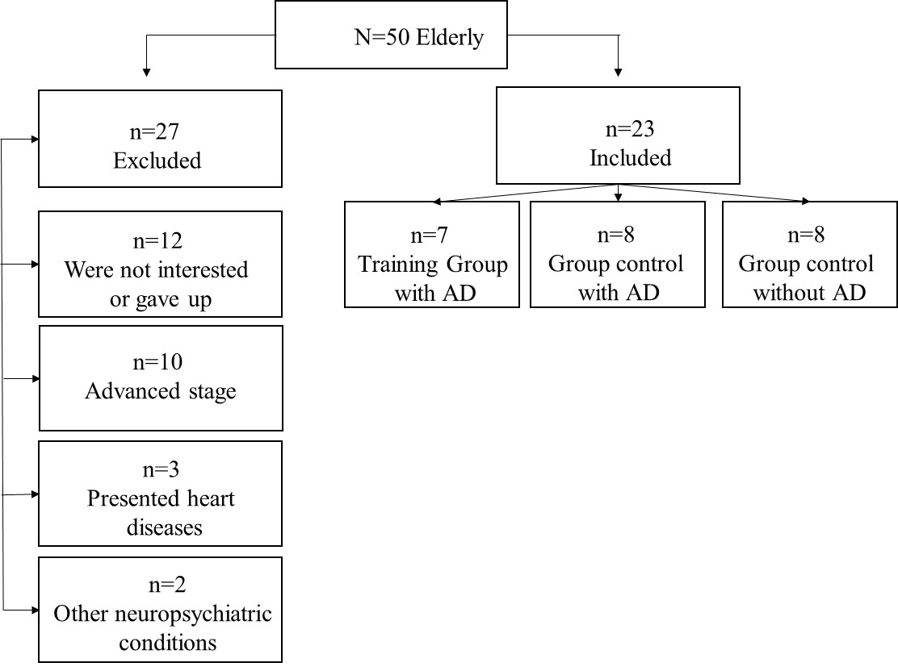
Figure 1.

Week | 1 | 2 | 3 | 4 | 5 | 6
Load | 2 times, 8 to 10 repetitions |  | 2 times, 10 to 15 repetitions |  | 3 times, 10 to 15 repetitions
Week | 7 | 8 | 9 | 10 | 11 | 12
Load | 3 times, 10 to 15 repetitions + load increase |  | 3 times, 10 to 15 repetitions + new exercises |  | 3 times, 10 to 15 repetitions + load increase
Figure 2.

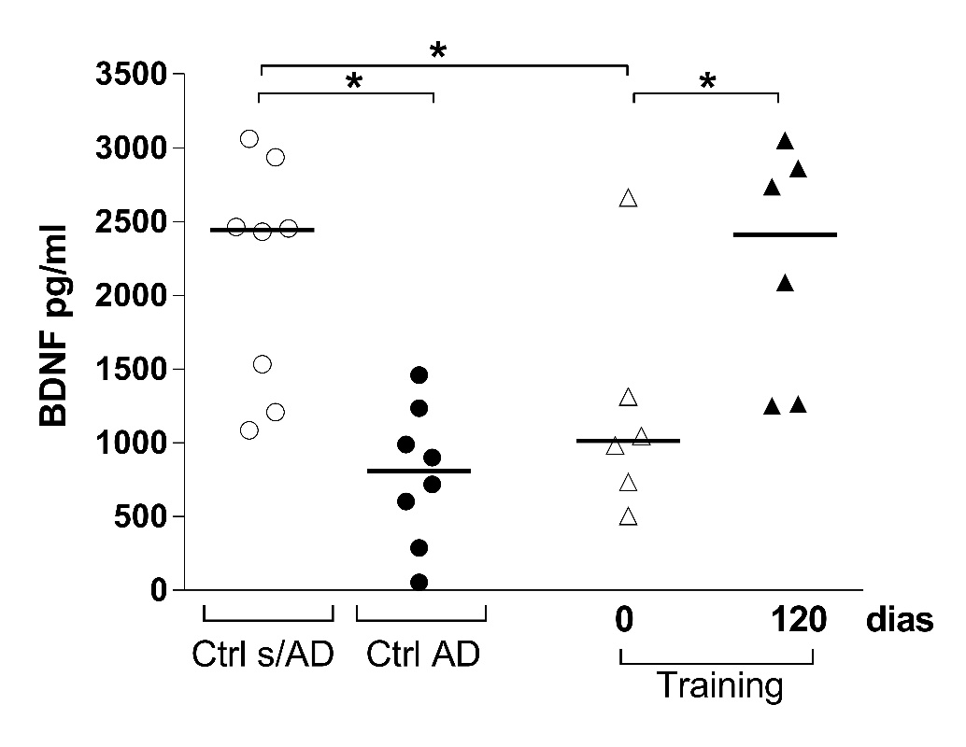
Figure 3.

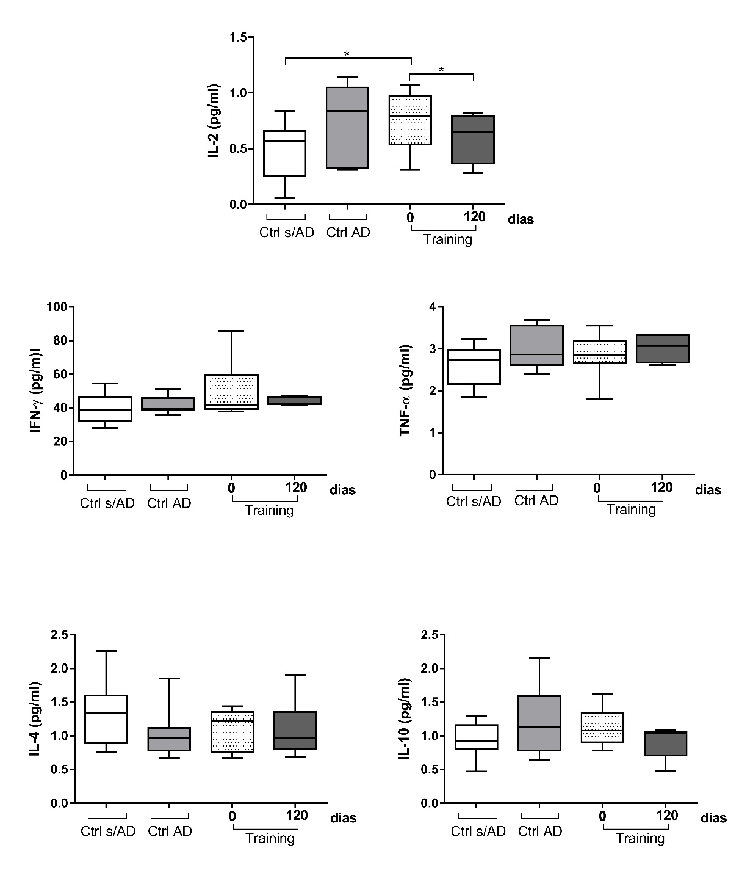

Figure 4.

